EQUATOR RESOLUTION
Institutional Mediation, Conciliation & Arbitration
www.equatorresolution.com · An Infrabyx Group Venture

Insurance Dispute Resolution
Platform Design, Legal Framework & Operating Blueprint
Resolving repudiated and short-settled claims, health and motor deductions,
mis-selling, delay and commercial-lines quantum disputes — fast, fair, and enforceable.

Document  Version / Date  Prepared for  Regulatory basis  Classification  Companion assets | Master Blueprint — Insurance Dispute Vertical  Version 1.0 · July 2026  Equator Resolution (Infrabyx Group)  Insurance Act 1938 (s.45) · Insurance Ombudsman Rules 2017 (am. 2021) · IRDAI circular 27 Oct 2023 (arbitration clauses) · IRDAI PPHI Regulations 2024 · Consumer Protection Act 2019 · Mediation Act 2023 · Arbitration & Conciliation Act 1996 · DPDP Act 2023  Strictly Confidential — Internal & Advisory  Products & Disputes Compendium · Authorities & Citations Digest · BI & Emerging-Risk Supplement · Forms Pack (F-I01–F-I26) · Developer Workbook · Diagrams · Calculators · Rules & Tariff · Practice Guides · Deck · Prototype

Important Notice, Scope & How to Use This Document
This Blueprint guides the build-out and operation of Equator Resolution's Insurance Dispute Resolution vertical. It frames the opportunity, sets out the legal and regulatory framework governing insurance disputes in India, maps the forums a policyholder or insurer may use, and specifies the platform, forms and procedure that the product and operations teams will implement.
Insurance is unlike Equator's other verticals in one decisive respect: the State has already built a dedicated, free, policyholder-friendly forum — the Insurance Ombudsman — and a regulator with a live grievance system, Bima Bharosa. Equator does not compete with either. Equator's role is to do the three things those institutions structurally cannot do at scale: (1) prepare a dispute properly so that it succeeds wherever it goes; (2) obtain a negotiated commercial outcome where the legal position is genuinely contestable and both sides would rather settle than litigate; and (3) convert whatever is agreed into a document that is enforceable as a decree of court under section 27 of the Mediation Act, 2023. Every intake in this vertical begins by telling the party what the Ombudsman can do for them for free.
The legal content is layered: each area opens with a plain-language summary, then deeper analysis, with statutes, regulations and circulars flagged in “Legal Basis” boxes and consolidated in the annexures. The law is stated as at July 2026.
How this Blueprint relates to its companions
This Blueprint is the *system*: the opportunity, the legal framework, the process, the data model, the economics and the controls. Three companion documents carry the *content* in exhaustive form and should be read alongside it. The Products & Disputes Compendium catalogues every line of insurance written in India, every recurring dispute, the forum that decides it, the document that resolves it and whether it is mediable — with the master routing and mediability matrices, worked numericals, decision trees and the table of verified authorities. The Authorities & Citations Digest treats each authority by doctrine for counsel, with the IRDAI turnaround-and-interest regime. The Business Interruption & Emerging-Risk Supplement covers pandemic, cyber, parametric and climate exposures. Where this Blueprint summarises a line in a sentence, the Compendium develops it in full.
RISK / CAUTION
This document is not a substitute for case-specific legal advice. Equator is neutral: it does not represent the policyholder or the insurer, does not practise law, and does not express a view on whether a claim would succeed. The Insurance Ombudsman, IRDAI, the consumer commissions and the Motor Accidents Claims Tribunals are statutory forums that Equator does not replace and must never appear to replace. Any communication that could give a party the impression that using Equator forecloses those remedies is a compliance breach.

Document control & approval
Field | Detail
Owner | Head of Legal & Product, Equator Resolution
Reviewers | General Counsel · Head of Operations · Head of Technology · Data Protection Officer
Approval | Board of Equator Resolution (Infrabyx Group)
Review cycle | Every six months, or on any amendment to the Insurance Ombudsman Rules, the IRDAI regulations or the Mediation Act
Law stated as at | July 2026
Verification protocol | Every statutory limit, monetary threshold and statistic is either sourced in Annexure A or marked [verify] and listed in the platform-level [verify] register

How to read the “[verify]” marks
Where a figure or a legal position is genuinely open — because a Bill has been passed but not brought into force, because draft guidelines have not been finalised, or because a statistic is published annually and the latest edition may have superseded ours — it is marked [verify]. These are not gaps in the work; they are the points at which a reader must check the primary source before relying on the sentence. The platform-level *[verify] Register* lists every one of them with an owner and a check date.

Table of Contents
This document uses Word heading styles. Open in Microsoft Word and choose “Update Field” on the entry below to generate a clickable, page-numbered contents list.
Right-click and choose “Update Field” to build the Table of Contents.

PART A
The Opportunity — Insurance Disputes in India
1. A1. Why insurance disputes are different
An insurance dispute is a contract dispute in which one party wrote the contract, holds the evidence, decides the claim in the first instance, and is a repeat player; the other party is usually facing the worst week of their life.
That asymmetry defines everything about how the vertical must be designed. In a commercial dispute the parties are broadly matched. In an insurance dispute the insurer has drafted the wording, controls the surveyor and the investigator, holds the claim file, has decided the claim once already, and will see thousands more like it. The policyholder is typically dealing with a death, a hospitalisation, a fire or a wrecked vehicle, has read the policy for the first time only after the loss, and will have exactly one insurance dispute in their life.
Three consequences follow, and they run through every design decision in this Blueprint:
- Information asymmetry must be corrected before bargaining begins. Equator's first substantive act in every case is to obtain the claim file, the survey or investigation report and the exact wording relied on, and to put them in front of both sides. A negotiation conducted where only one party can see the evidence is not mediation; it is attrition.
- The policyholder must never be worse off for coming to us. Because a free statutory forum exists, any process that consumes the policyholder's one-year Ombudsman window without settling is a net harm. Timelines and last-dates-to-act are therefore a compliance control, not a nicety — they appear on the intake form, the triage record, the closure report and the case-room screen.
- Repeat-player capture is the principal integrity risk. The insurer will be a repeat user; the policyholder will not. Neutral rotation, appointment-count publication, cooling-off and outcome-monitoring by insurer are not optional governance garnish — they are the thing that makes the vertical credible.

2. A2. The size and shape of the problem
Insurance grievances in India are numerous, growing, and concentrated in a small number of recurring patterns. The public data points below frame the opportunity; each is sourced in Annexure A.
Indicator | Position | Source / note
Complaints received by the 17 Insurance Ombudsman centres, 2023-24 | 52,575 received; 49,705 disposed of, of which 12,855 were treated as non-entertainable | Council for Insurance Ombudsmen, Annual Report 2023-24
Outcomes issued, 2023-24 | 15,528 recommendations; 9,287 awards in favour of the complainant; 8,638 awards in favour of the insurer | Council for Insurance Ombudsmen, Annual Report 2023-24 [verify — composition of the figures]
Change year on year | Over 43% increase in total disposal; roughly 50% reduction in non-entertainable complaints | Council for Insurance Ombudsmen, Annual Report 2023-24
Grievances registered on Bima Bharosa (IRDAI's grievance system), 2023-24 | 2,15,569 in total, of which 1,20,726 related to life insurance | IRDAI Annual Report 2023-24 [verify — latest edition]
Complaint mix by line | Health is the single largest source of general-insurance grievances; life accounts for the majority of all grievances by volume | IRDAI / CIO reporting [verify — current split]
Most-complained life product | Endowment and other savings-linked products dominate mis-selling complaints | CIO reporting [verify]
Direction of travel | Complaint volumes and contested claim values have both been rising | [verify — current quarter figures]

PRACTICAL SUMMARY
The number that matters commercially is not the complaint count but the non-entertainable count. Roughly one in four complaints reaching the Ombudsman in 2023-24 could not be entertained — usually because the policyholder had not first made a written representation to the insurer, had missed the one-year window, had exceeded the monetary limit, or had a matter already pending elsewhere. That is the single clearest statement of the gap Equator fills: most rejected complaints fail on process, not on merits. A vertical that does nothing but get the process right would justify itself.

3. A3. The recurring dispute patterns
Across lines of business, insurance disputes cluster into a small number of shapes. The taxonomy in Part E is built on these; so are the forms, the AI classifier and the neutral training curriculum.
Pattern | What it looks like | Typical line | Why it settles
Repudiation on non-disclosure | Claim rejected because a fact was not disclosed at proposal | Life, health | Materiality and, for life, the section 45 timeline are both contestable; insurers frequently prefer a negotiated outcome to an adverse award
Pre-existing disease / waiting period | Claim rejected or reduced because a condition is said to pre-date the policy | Health | Continuity of cover and portability credit are objectively checkable; the dispute is usually about records, not law
Deduction stack | Claim admitted but heavily reduced — room-rent proportionality, co-pay, sub-limits, non-medical items | Health | Each deduction is separately arguable; splitting the difference across a line-item schedule is a natural mediated outcome
Delay | Claim neither paid nor rejected for months | All | Interest for delay is a cheap concession for the insurer and a real win for the policyholder
Mis-selling | Product sold as a deposit, a guaranteed return, or a condition of a loan | Life, especially bancassurance | Refund, conversion or premium waiver are all available; reputational exposure gives the insurer an incentive
Quantum / survey dispute | Loss admitted; the assessed figure is disputed | Motor, fire, marine, engineering | Two professional assessments and a number in between — the classic mediated settlement
Underinsurance / average | Payment cut proportionately because the sum insured was below the value at risk | Commercial property | The valuation basis is usually arguable and the insured's broker is often willing to contribute
Policy-condition breach | Repudiation for a licence, permit, intimation-delay or warranty breach | Motor, commercial | Non-standard settlement (a percentage of the assessed loss) is established market practice
Nomination / heirship | Insurer holds the money pending competing claims | Life | Not a dispute with the insurer at all — a dispute between claimants, which is pure mediation territory

4. A4. Where Equator adds value — and where it must not
4.1 A4.1 The four value propositions
- Preparation. The claim file, the survey report, the exact wording, a ground-by-ground schedule and a line-item deduction table. Whether the matter then settles at Equator or is decided by the Ombudsman, the party arrives prepared. Given that a quarter of Ombudsman complaints are non-entertainable, this alone moves outcomes.
- Speed. A mediated settlement in 30–45 days against an Ombudsman process that may take several months and a consumer commission that may take years.
- Scope. The Ombudsman decides the claim. Mediation can deliver what an award cannot: reinstatement of the policy with continuity of waiting periods, withdrawal of an adverse remark or fraud flag, conversion of a mis-sold product, a structured payment, a written correction, or a package that resolves three claims at once.
- Enforceability. A settlement signed and registered under the Mediation Act, 2023 is enforceable as a decree of court. There is no further round.

4.2 A4.2 The five hard limits
- Equator is not the Ombudsman. No branding, copy, email or AI output may suggest otherwise. Every intake carries the Ombudsman signposting.
- Equator does not advise on the merits. Neither the case manager nor the neutral tells a party whether the claim is good. The AI explorer is hard-constrained against merits opinions and against predicting claim value.
- Retail policies have no arbitration. Equator will not administer an arbitration on a retail policy, will not draft an arbitration clause into a retail policy, and will flag any retail policy that contains one.
- Statutory rights are not tradeable. No settlement may recite that a party gives up the right to approach the Ombudsman, a consumer commission or a court in respect of a *different* claim, or waives a right that cannot be contracted away.
- Fraud is not mediated. Where an insurer alleges fabricated documents or a staged loss, the matter is either investigated or litigated. Equator will mediate the *consequences* of a fraud allegation — withdrawal of a flag, a walk-away — only where both sides ask for that expressly.

5. A5. Who the customers are
Segment | What they want | How Equator reaches them | Commercial model
Individual policyholders and claimants | The claim paid, quickly, without a lawyer, and to be told honestly what their options are | Search, the AI Dispute Explorer, hospital and garage referral, consumer groups, vernacular content | Low flat filing fee with waivers; success-linked component where permitted
Nominees and legal heirs | Release of a death claim held up by documentation or competing claims | Life-insurer referral, funeral and estate services, legal-aid tie-ups | Flat fee; often the insurer pays under an institutional protocol
MSMEs and mid-market corporates | A quantum dispute on a fire, marine or engineering policy resolved without a two-year arbitration | Brokers, industry associations, the Commercial vertical's existing pipeline | Ad valorem tariff
Insurers | Fewer Ombudsman awards, lower legal spend, better complaint metrics, a defensible audit trail, and a way to settle a book of small disputes at once | Direct institutional sale to the claims and legal function; standing protocol | Annual subscription plus per-case fee; volume tiers
Brokers and corporate agents | A way to keep a client whose claim has gone wrong | Broker channel partnerships | Referral protocol; no fee sharing that would compromise neutrality
TPAs and hospitals | Resolution of cashless denials and package-rate disputes without the patient in the middle | Hospital tie-ups | Per-case fee, usually insurer-borne
Employers with group cover | Employee health claims resolved without the HR team mediating | Cross-sell from the Workplace vertical | Retainer

PRACTICAL SUMMARY
The insurer-side sale is the one that makes the vertical work. An insurer that receives 20,000 grievances a year and loses a meaningful proportion of Ombudsman awards has a measurable, budgeted problem. Equator's pitch to that insurer is not “be nicer”; it is “settle the settleable ones early, at a lower total cost, with a decree-grade document and an audit trail you can show the regulator”.

PART B
The Legal & Regulatory Framework
6. B1. The architecture in one page
Five instruments do the work. Everything else is detail.
Instrument | What it governs | Why it matters to Equator
Insurance Act, 1938 (as amended, including by the Sabka Bima Sabki Raksha (Amendment of Insurance Laws) Act, 2025) | The contract of insurance, the regulator's powers, and — in section 45 — the limits on an insurer calling a life policy in question | Section 45 decides a large share of life repudiation disputes on dates alone
Insurance Ombudsman Rules, 2017 (amended 2021, and further amended thereafter) | The free statutory forum: 17 centres, jurisdiction, limits, procedure, awards | The alternative every policyholder must be told about; also the benchmark against which Equator's speed and scope are judged
IRDAI circular dated 27 October 2023 — Amendment of Arbitration Clause in General Insurance Policies | No arbitration clause in retail policies; commercial policies may have a separately agreed arbitration agreement | The single structural rule that splits the vertical in two
IRDAI (Protection of Policyholders' Interests, Operations and Allied Matters of Insurers) Regulations, 2024 | Policy servicing, claim turnaround, grievance redressal machinery, conduct at point of sale | The source of the insurer-side obligations Equator holds insurers to in mediation
Consumer Protection Act, 2019 and the Mediation Act, 2023 | The consumer commissions; and mediation, its confidentiality and the enforceability of settlements | The consumer route is an independent right that cannot be ousted; section 27 makes Equator's output enforceable

7. B2. The retail / commercial split — the rule that shapes the vertical
LEGAL BASIS
IRDAI circular dated 27 October 2023 — “Amendment of Arbitration Clause in General Insurance Policies”. Retail general-insurance policies shall not contain an arbitration clause. For commercial policies, the parties may, by mutual agreement, enter into a separate arbitration agreement covering any and all disputes. The Delhi High Court has since upheld the binding character of such a separately agreed arbitration provision in a commercial context. [verify — case citation and current status]

This is the most consequential rule in the vertical, and it is easy to get wrong in a way that harms a policyholder. Its practical effects are these:
- A retail policyholder cannot be pushed into arbitration. If a retail policy still carries a legacy arbitration clause — many pre-2023 wordings do — that clause is not a bar. The policyholder's route is the insurer's grievance cell, the Insurance Ombudsman, a consumer commission or a civil court.
- Equator will not administer a retail arbitration. The intake system blocks it at the form level, the database blocks it at the constraint level, and the AI explorer is instructed never to suggest it.
- Commercial parties may arbitrate, but only if they separately agree. The agreement must be a distinct agreement, mutually entered into, and must cover any and all disputes rather than being partial. Equator's model commercial arbitration agreement in the Model Clauses annexure is drafted to that standard.
- In every case the consumer route survives. The Supreme Court has repeatedly held that a consumer's statutory remedy is an additional remedy and is not ousted by an arbitration clause. An insurer's assertion to the contrary in a mediation is a point the case manager should correct on the record.

RISK / CAUTION
The single worst compliance failure available in this vertical is to route a retail policyholder into arbitration — slower, costlier, and in place of a free forum designed for exactly this person. Controls: (1) the retail/commercial question is mandatory on Form F-I02 and cannot be skipped; (2) the triage record F-I13 requires a separate classification and reviewer sign-off; (3) the case database rejects an arbitration route on a record classified retail; (4) the AI explorer's guardrail set contains an explicit prohibition tested in the evaluation harness.

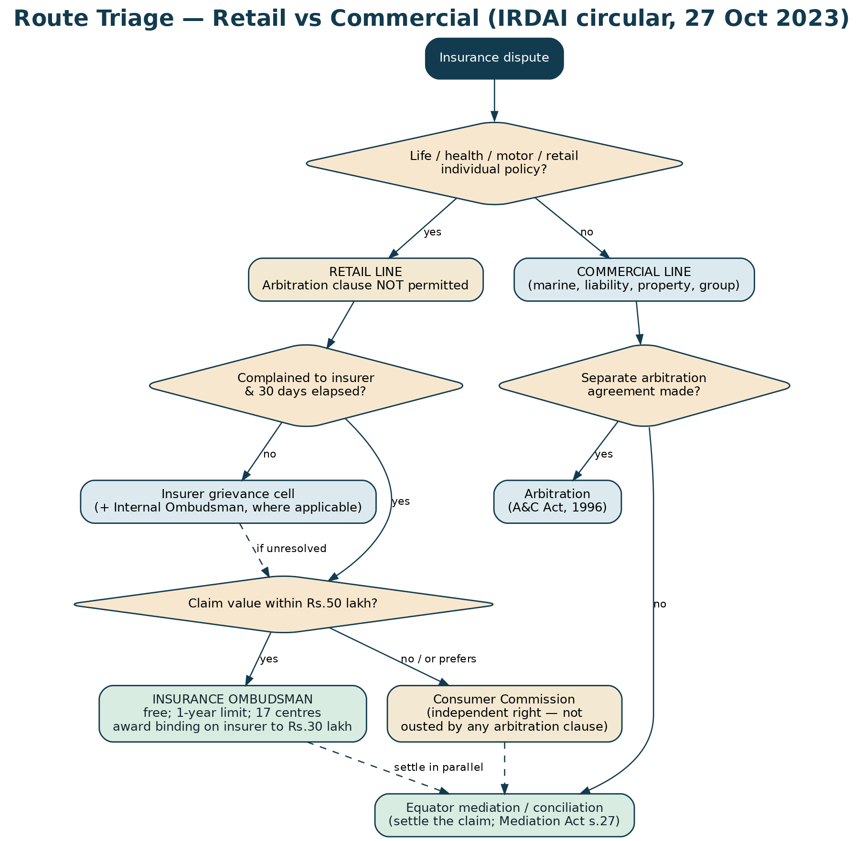
Figure B-1: Route triage. The retail/commercial classification determines everything downstream.
8. B3. The Insurance Ombudsman — the forum Equator must always name
8.1 B3.1 What it is
The Insurance Ombudsman is a statutory grievance-redressal institution established under the Insurance Ombudsman Rules, 2017, administered through the Council for Insurance Ombudsmen. There are 17 centres. It is free, requires no lawyer, and accepts electronic filing and online tracking. For an individual policyholder with a claim within its limits, it is almost always the correct first escalation — and saying so plainly is a condition of Equator operating honestly in this market.
8.2 B3.2 Jurisdiction, limits and procedure
Element | Position | Practical note
Who may complain | An individual policyholder or claimant, personally or through a legal heir, nominee or assignee | Corporates are outside the scheme — a commercial insured must use the consumer commission (if it qualifies), a civil court, or arbitration if agreed
Grounds | Delay in settlement; partial or total repudiation; premium disputes; misrepresentation of terms; legal construction of the policy so far as it relates to a claim; policy servicing; non-issue of a policy after receipt of premium; and, since 2021, deficiency in service generally | The 2021 amendment widened the scheme from “disputes” to deficiency in service and brought brokers and other intermediaries within its ambit — which is what makes mis-selling complaints viable
Precondition | A written representation to the insurer which has been rejected, or to which no reply was received within 30 days, or where the reply is unsatisfactory | This is the most common reason complaints are not entertained. Form F-I04 exists solely to get it right
Time limit | Within one year of the insurer's reply or of the expiry of the 30-day period | Equator must calculate and communicate this date at intake. Mediation does not extend it
Monetary jurisdiction | Claims up to ₹50 lakh | Above that, the consumer commission or a civil court
Binding effect of an award | Binding on the insurer up to ₹30 lakh; not binding on the complainant | The asymmetry is deliberate and is a genuine advantage for the policyholder
Time to award | Ordinarily within three months of receipt of all requirements | In practice, longer where documents are incomplete
Compliance | The insurer must comply and confirm compliance within 30 days of receiving the complainant's acceptance | Non-compliance is itself reportable to IRDAI
Cost | Free | No fee, no lawyer required, hearings may be attended in person or by video
Bar | Not entertainable if the same subject-matter is pending before, or has been decided by, a court, consumer commission or arbitrator | This is why parallel filing must be sequenced deliberately — see B3.4

Before filing, confirm the current monetary limits and the centre list on the Council for Insurance Ombudsmen's website: the Rules have been amended more than once and a further gazette amendment was notified in November 2025. [verify — limits and centre list at the date of filing]
8.3 B3.3 How the Ombudsman actually works — recommendation, then award
The process has two stages, and the first is itself a mediation. The Ombudsman may make a recommendation which, if accepted by both sides, disposes of the complaint. Only if that fails does an award follow. This matters for Equator in two ways: it confirms that insurers do settle these disputes when a neutral frames the outcome; and it means an Equator mediation running in parallel is doing the same work the Ombudsman would do at stage one, sooner.
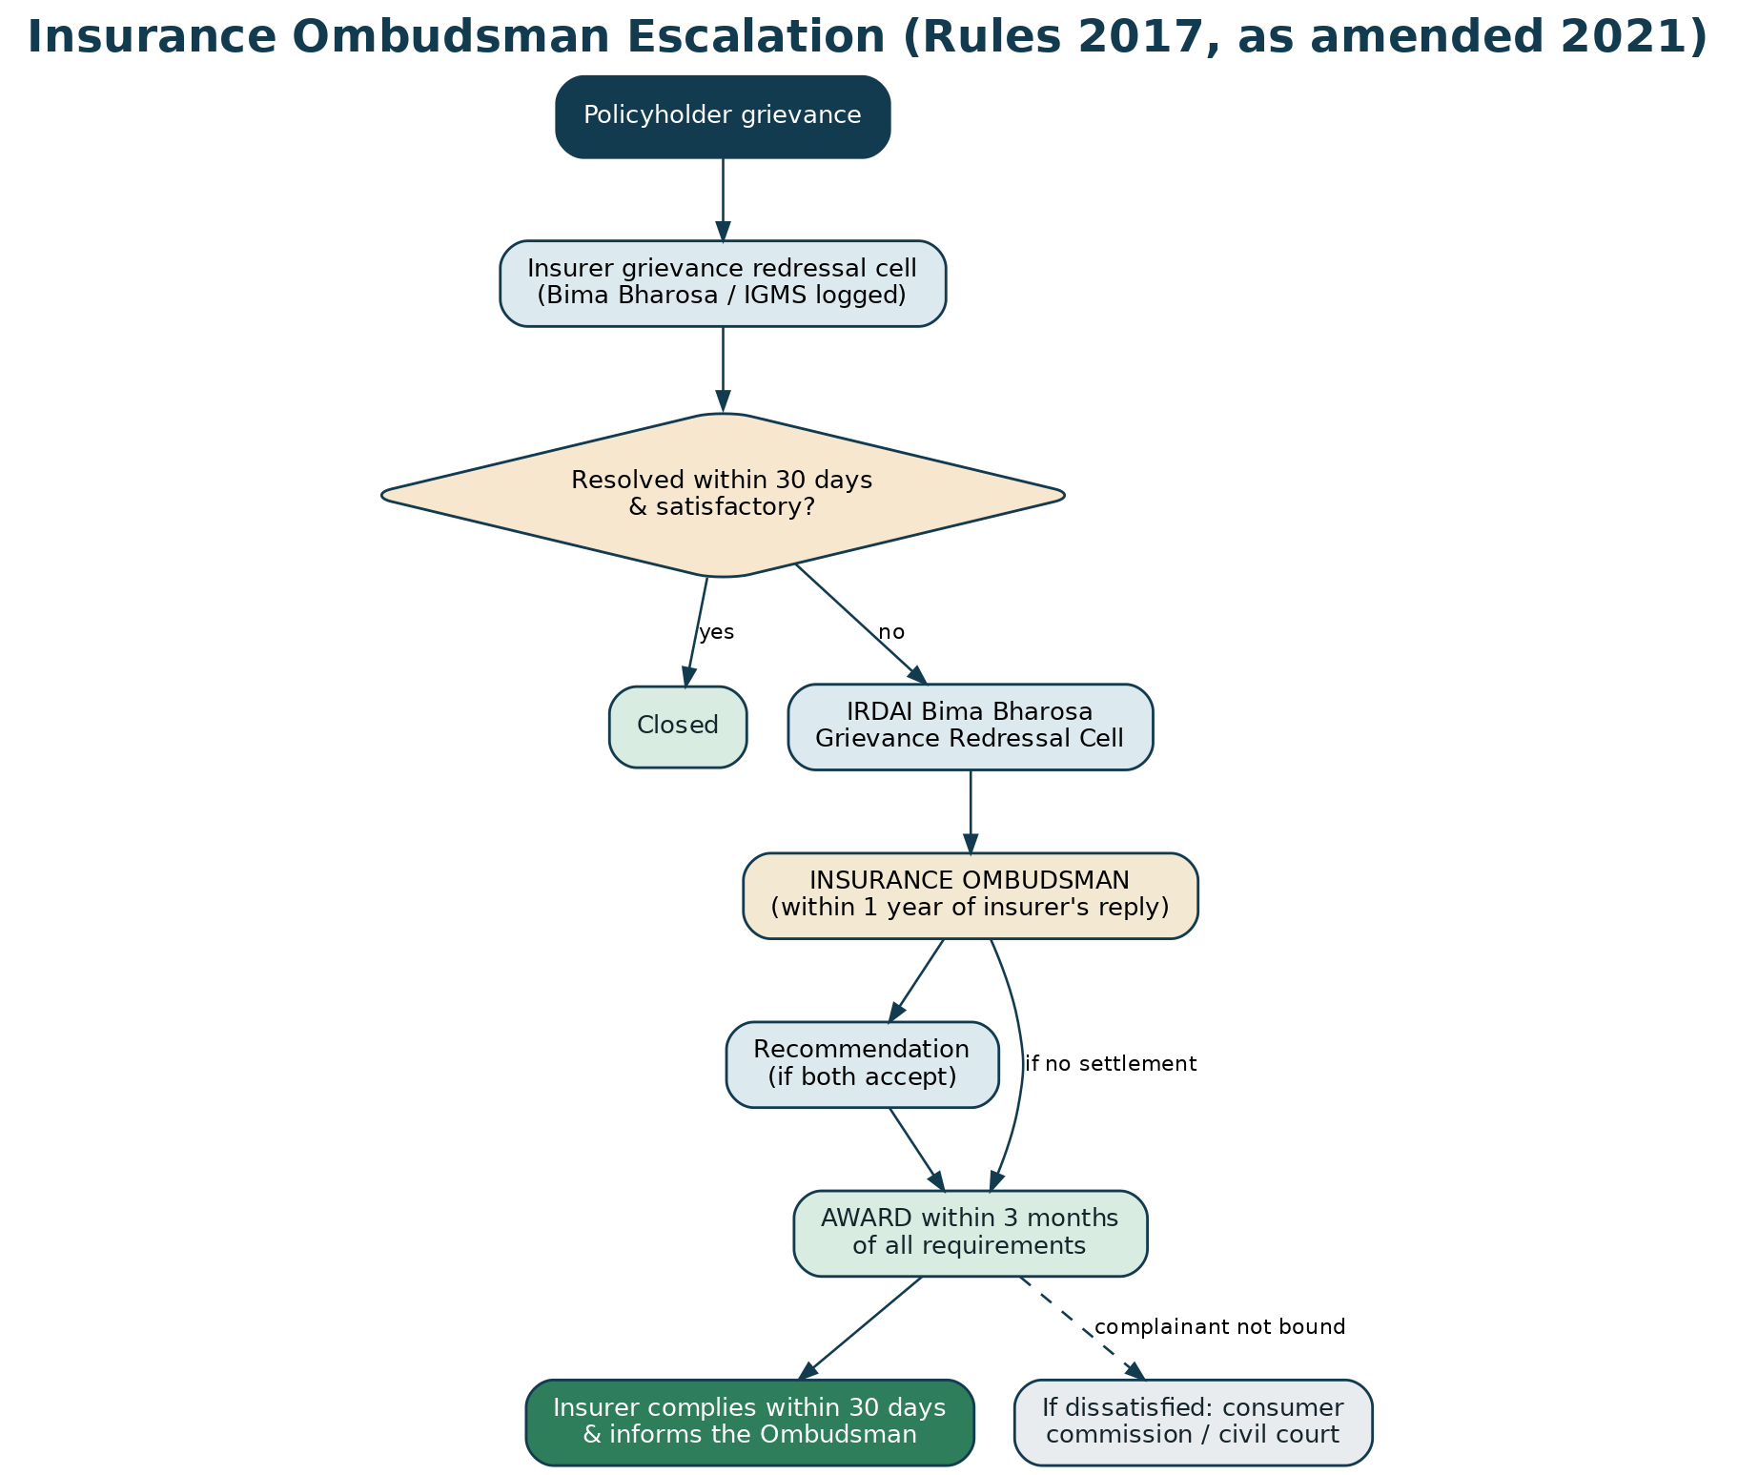
Figure B-2: The Ombudsman escalation path, from insurer grievance cell to compliance.
8.4 B3.4 Sequencing Equator against the Ombudsman — the rule that protects the party
Because a complaint is not entertainable if the same subject-matter is pending before a court, consumer commission or arbitrator — and because the one-year window runs regardless — the sequence must be managed deliberately. Equator's standing rule:
SEQUENCING RULE
Mediate early and in parallel with, or ahead of, the Ombudsman filing — never instead of it, and never so late that the one-year window closes. At intake, calculate the last date to file with the Ombudsman and put it in writing. If mediation has not produced a settlement 60 days before that date, the case manager must prompt the party to file, and record that they have done so. Note that an Ombudsman complaint is not itself a bar in the way a court, commission or arbitration is — but a pending court or commission case is, so a party who has already filed in a consumer commission cannot then go to the Ombudsman on the same subject-matter.

COMPLIANCE NOTE
Control IN-C-01: the case-management system will not permit closure of an insurance matter without a completed signposting table (Form F-I19 section C) showing, for each available forum, the last date on which the party may act. This is tested in the UAT pack and audited quarterly.

9. B4. Bima Bharosa, the regulator, and the internal ombudsman
9.1 B4.1 Bima Bharosa
Bima Bharosa is IRDAI's online grievance system for policyholders, which replaced the older Integrated Grievance Management System (IGMS) in 2023. A grievance registered there is routed to the insurer, tracked, and escalates to IRDAI's Grievance Redressal Cell if unresolved. It is free, multi-lingual, and integrates with Bima Sugam, the insurance electronic marketplace notified by IRDAI in March 2024, whose first phase went live in December 2025. [verify — current Bima Sugam scope and phases]
PRACTICAL SUMMARY
Always register on Bima Bharosa in addition to writing to the insurer. The token number is contemporaneous, third-party proof of the date and content of the grievance, and both the Ombudsman and the consumer commission treat it as such. It costs nothing and takes minutes. Equator's intake flow prompts for the token and stores it on the case record.

9.2 B4.2 The proposed Internal Insurance Ombudsman
IRDAI issued the Draft IRDAI (Internal Insurance Ombudsman) Guidelines, 2025 on 23 July 2025, with consultation closing on 17 August 2025. As drafted, they would apply to all insurers (excluding reinsurers) that have completed three years of operations; require an internal ombudsman with at least 20 years' insurance experience who has never been associated with the appointing insurer and has held a position no lower than two levels below a board-level director; give jurisdiction over claims up to ₹50 lakh; and require a reasoned decision on merits, typically within 15 days, on complaints unresolved beyond 30 days or rejected and then appealed. [verify — whether the Guidelines have been finalised and notified, and their commencement date]
RISK / CAUTION
If and when the internal ombudsman becomes mandatory, it inserts a further mandatory internal step before the statutory Ombudsman. Equator's triage logic, forms F-I04 and F-I13, the AI routing rules and the signposting table must all be updated on notification. This is on the six-monthly review checklist as a named item, with a nominated owner.

10. B5. The consumer route — an independent right
A policyholder is a “consumer” and a deficiency in insurance service is actionable under the Consumer Protection Act, 2019. Two propositions matter:
- The consumer remedy is additional, not alternative. It is not ousted by an arbitration clause. An insurer's suggestion in a mediation that the policyholder “has to arbitrate” should be corrected.
- But it is not free of consequence. Once a consumer complaint is filed, the same subject-matter is no longer entertainable by the Ombudsman. Filing order therefore matters, and Equator must explain it before, not after, the party files.

Forum | Pecuniary jurisdiction (goods/services value) | Note
District Commission | Up to ₹50 lakh | Filing is inexpensive; a lawyer is not required
State Commission | Above ₹50 lakh and up to ₹2 crore | Appeals from District Commissions lie here
National Commission (NCDRC) | Above ₹2 crore | Appeals from State Commissions lie here
Limitation | Ordinarily two years from the cause of action | Condonation is possible but not assured

[verify — current pecuniary limits, which have been revised by notification more than once]
11. B6. Section 45 of the Insurance Act, 1938 — the date test in life claims
LEGAL BASIS
Section 45 restricts an insurer from calling a life policy in question after the statutory period running from the later of the date of issue of the policy, the date of commencement of risk, the date of revival, or the date of the rider. Within that period the insurer may act only on the grounds the section permits — fraud, or misstatement of or suppression of a material fact — and only by following the procedure it prescribes, including communicating the ground in writing to the insured or the nominee, with the materials on which the decision is based. [verify — current text and the applicable period]

Two practical points, which the neutral training curriculum drills:
- Check the dates before anything else. A repudiation issued outside the section 45 window on a non-disclosure ground is vulnerable on the face of it. A significant proportion of life repudiation disputes are decided on this arithmetic and nothing else. Revival resets the clock — so a policy revived after lapse may be inside the window even though the original policy is old.
- Check the procedure. Where the ground was not communicated in writing with the supporting materials, the repudiation is procedurally exposed regardless of the merits. Form F-I11 asks this question directly.

PRACTICAL SUMMARY
This is the clearest illustration of the vertical's core insight. The policyholder rarely knows section 45 exists. The insurer's claims officer does. Correcting that asymmetry — by asking eight structured questions on a form — changes the negotiation before anyone has argued about the merits.

12. B7. The interpretive principles that decide insurance disputes
Principle | What it means | Where it bites
Materiality | A non-disclosure defeats a claim only if the undisclosed fact was material to the risk, judged as at the proposal | Life and health repudiations. A condition that was trivial, resolved, or would not have altered underwriting is not material
Proximate cause | The dominant, effective cause of the loss must be a covered peril | Motor, fire, marine. A chain of events with an excluded link somewhere in it does not automatically defeat the claim
Contra proferentem | Ambiguity in a document drafted by the insurer is construed against the insurer | Exclusion clauses, sub-limits, definitions of “hospital”, “accident”, “pre-existing”
Reasonable expectations / fair dealing | An exclusion buried, unexplained or illegible at the point of sale carries less weight | Bancassurance and telesales mis-selling
Nexus between breach and loss | A technical breach of condition without any connection to the loss should not defeat the whole claim | Motor licence, permit, fitness and intimation-delay repudiations — the origin of non-standard settlements
Uberrima fides, both ways | Utmost good faith binds the insurer as much as the insured | Delay, shifting grounds of repudiation, and failure to share the survey report

HOW EQUATOR USES THESE
Not to decide the claim — Equator never does that — but to structure the conversation. Form F-I05 runs the four tests as an explicit grid. When a neutral asks an insurer's officer to identify, in writing, which test the repudiation satisfies and on what document, weak grounds tend to be withdrawn and strong ones tend to be conceded. That is the mechanism by which this vertical produces settlements.

13. B8. Line-by-line: what actually goes wrong, and what the law says
The general principles in B7 are applied through line-specific rules and market practice. This section is the reference the case manager and the neutral work from; it is mirrored in Forms F-I09 to F-I12 and in the practice guides.
13.1 B8.1 Health insurance
Health is the largest single source of general-insurance grievances in India, and the disputes are remarkably repetitive. Six issues account for most of them.
Issue | The insurer's position | The counter-position | What settles it
Pre-existing disease (PED) | The condition existed before the policy and the waiting period is not complete | Continuous cover means the waiting period is already complete; or the condition was disclosed; or it was not material; or the medical record does not establish pre-existence | The policy inception date (the first ever policy if ported), the renewal chain, and the proposal form. Portability ordinarily carries continuity credit for waiting periods
Room-rent capping and proportionate deduction | A room above the eligible category was taken, so all associated charges are reduced proportionately | The proportionate deduction was not clearly disclosed; or the higher room was medically necessary or the only one available; or the deduction has been applied to charges that do not vary with room category | Line-item analysis. Surgeon's fees and implants often do not vary with the room; that is a standard and effective concession
Co-pay and sub-limits | The policy caps this head of expenditure | The cap was not explained at the point of sale; or has been applied twice; or has been applied to the wrong head | The wording, and arithmetic. Double-counting is common and is conceded once shown
Non-medical / consumable items | Consumables are excluded | Some items charged as consumables are integral to the procedure | The itemised bill against the standard exclusion list. Partial allowance is the usual landing point
Cashless denial | Ineligible at the pre-authorisation stage | Pre-authorisation is a preliminary view, not a claim decision; reimbursement remains open | Almost always resolved by converting to reimbursement and arguing the substance
“Not medically necessary” / day-care | The treatment could have been taken as an outpatient | The treating doctor's certificate says otherwise; the procedure is on the day-care list | The treating doctor's note usually carries the day, absent contrary specialist opinion

PRACTICAL SUMMARY
The most powerful single document in a health dispute is the line-item deduction schedule in Form F-I09 section B. Insurers rarely receive one. When each deduction has to be justified in its own row, with the clause and the amount, weak deductions fall away without argument. In Equator's design assumptions this is the mechanism that produces the majority of health settlements.

LEGAL BASIS
The IRDAI (Protection of Policyholders' Interests, Operations and Allied Matters of Insurers) Regulations, 2024 govern claim turnaround, the obligation to give reasons, and grievance machinery. Health-specific product regulation (including portability and continuity credit) sits in the health insurance regulatory framework. [verify — exact turnaround timelines and the current health regulation citation]

13.2 B8.2 Motor insurance
Issue | Position | Practical resolution
IDV | The Insured's Declared Value fixes the ceiling for own-damage and total-loss claims and is agreed at inception | Where IDV was set by the insurer's system and is demonstrably below market, insurers do sometimes improve the offer; the argument is stronger where the renewal was automatic
Depreciation on parts | Standard scales apply unless a zero-depreciation add-on was purchased | Check what add-ons were actually sold; mis-sold or wrongly-omitted add-ons convert a quantum dispute into a mis-selling one
Salvage | Salvage value is deducted where the insured retains the wreck | The valuation of salvage is the negotiable element; a competing quotation is the standard tool
Total loss / CTL | Declared when repair cost approaches a set percentage of IDV | Whether to declare total loss is often the real dispute; both sides have a number and the gap is mediable
Driving licence breach | Repudiation where the driver held no valid licence for the class of vehicle | The question is whether the breach was fundamental and had a nexus with the loss. Non-standard settlement — a percentage of the assessed loss — is established market practice and is the natural mediated outcome
Delay in intimation | Policy condition requires immediate intimation | Delay alone, without prejudice to the insurer's ability to investigate, is a weak ground; the market practice is again a non-standard settlement
Third-party injury or death | Not an Ombudsman or a consumer matter | The forum is the Motor Accidents Claims Tribunal. Equator's role is limited to mediating the quantum where the parties and the insurer wish, and to signposting

THE NON-STANDARD SETTLEMENT
Indian motor practice has a settled device for technical breaches: the insurer pays a percentage of the assessed loss — commonly 75% — rather than repudiating outright. It exists precisely because courts have declined to allow technical breaches to defeat claims. It is also, structurally, a mediated outcome that the market already accepts. A neutral who knows this can move a motor dispute from “repudiated” to “settled at a percentage” in a single session. [verify — the customary percentage and its regulatory basis]

13.3 B8.3 Life insurance
- Early death claims (within the first years of the policy) attract investigation as a matter of course. Investigation is legitimate; indefinite investigation is a delay dispute in disguise, and a firm date is a reasonable mediated ask.
- Non-disclosure is tested for materiality and against the section 45 timeline. Where the proposal form was completed by the agent, or where a medical examination was conducted and disclosed the condition, the insurer's position weakens considerably.
- Nomination and heirship disputes are not disputes with the insurer at all. The insurer is a stakeholder holding money. These are among the most mediable matters in the whole vertical and among the least well served by the existing forums: the Ombudsman decides insurer conduct, not competing family claims.
- Surrender, paid-up and bonus disputes are arithmetic disputes about the illustration against the actual computation; the benefit illustration signed at the point of sale is the key document.
- Lapse and revival disputes turn on whether the lapse notice was served, whether the grace period was correctly applied and whether a revival offer was made and refused.

13.4 B8.4 Commercial lines — fire, marine, engineering, liability
Commercial disputes are quantum disputes far more often than coverage disputes, and quantum disputes are what mediation does best.
Issue | The mechanics | The mediable element
Survey and assessment | A licensed surveyor assesses the loss; the report drives the offer | Whether the report was shared, whether the insured had a chance to comment, and whether a competing assessment exists. A joint re-survey or an agreed independent assessor is a standard mediated step
Underinsurance / average | Where the sum insured is below the value at risk, the claim is reduced in proportion | The valuation basis and the date of valuation. Where a broker set the sum insured, a three-way conversation involving the broker often unlocks the settlement
Basis of indemnity | Reinstatement value against market value against agreed value | Frequently a drafting mismatch between the schedule and the wording — resolved by construction, and contra proferentem helps the insured
Business interruption | Indemnity period, gross profit definition, standing charges, savings | Almost pure accounting. A jointly instructed forensic accountant is the classic mediated device
Warranty and condition precedent | Breach may defeat the claim entirely | The severity of the breach and its nexus with the loss; partial settlements are common
Co-insurance and reinsurance | Several insurers share the risk; the reinsurer may drive the decision | Alignment. A settlement that the lead insurer supports but the reinsurer has not approved will not hold — so the authority question in Form F-I14 must be answered before, not during, the session
Subrogation and recovery | The insurer pursues the third party after paying | Sharing of recoveries, and the insured's cooperation obligations — often a useful trading chip

Figure B-3: The commercial path. Arbitration is available only on a separate, mutually agreed arbitration agreement.
13.5 B8.5 Mis-selling
Mis-selling is the dispute class where the 2021 amendment to the Ombudsman Rules changed the landscape: by extending the scheme to deficiency in service and bringing agents, brokers and other intermediaries within its ambit, it made complaints about the conduct of the sale — not merely the insurer's decision on a claim — squarely entertainable.
- The recurring fact patterns are: a single-premium product sold as a fixed deposit; a guaranteed return represented that the product does not carry; insurance sold as a condition of a loan, locker or account; a lapsed policy “revived” by selling a new one; and medical disclosures omitted by the seller.
- The free-look period is the first and cleanest remedy — but it runs from receipt of the policy document, and the whole problem in a mis-sale is that the customer did not read it. Where the free-look has expired, the argument moves to misrepresentation.
- The evidence that decides it is the benefit illustration, the proposal form (particularly whether it was completed by the seller and whether it was signed blank), the call recording where the sale was by telephone, and the bank statement showing what the customer thought they were buying.
- The mediated outcomes available go well beyond a refund: conversion to a single-premium or paid-up policy, waiver of future premiums, substitution with a suitable product, or a partial refund with the cover continuing. An Ombudsman award cannot easily construct these; a settlement can.

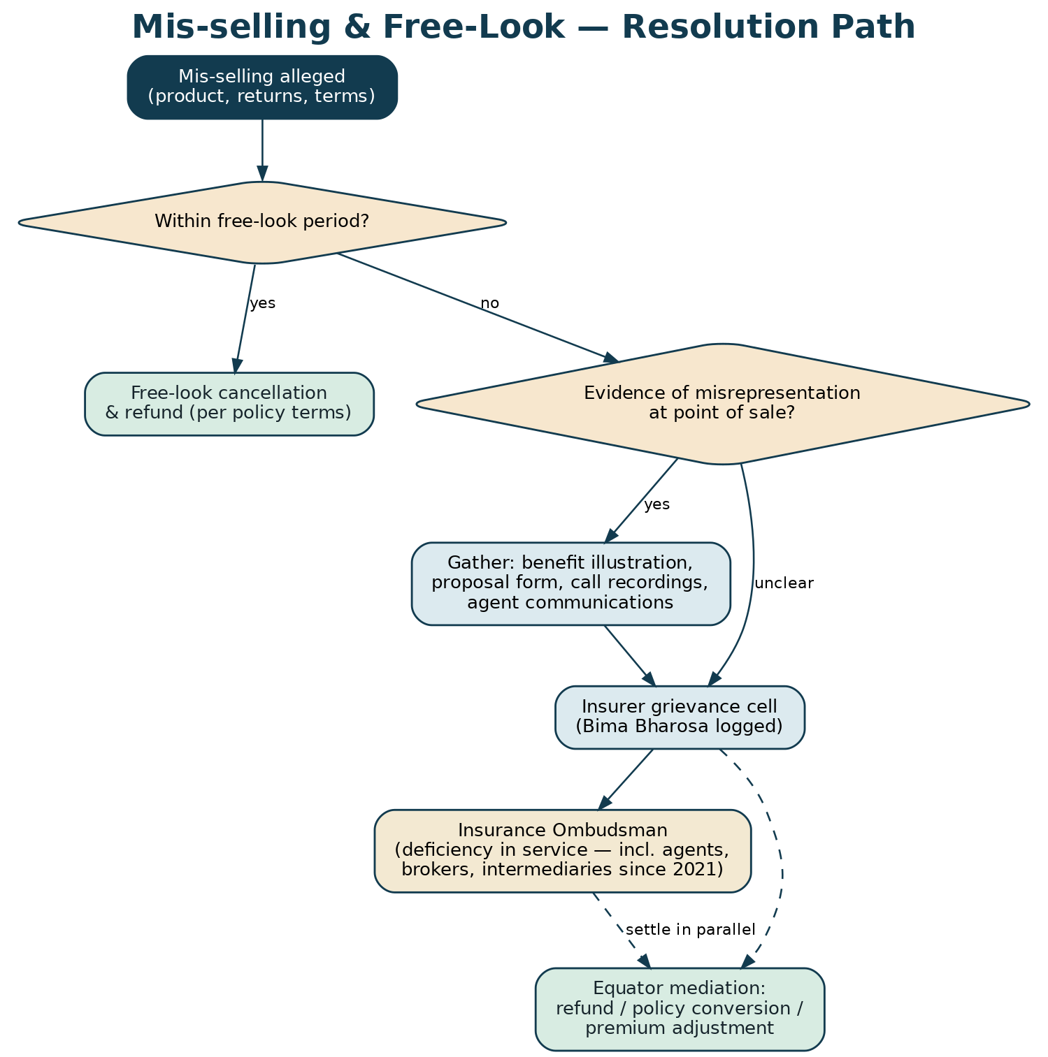
Figure B-4: The mis-selling and free-look path.
14. B9. Data protection and health data
Insurance disputes involve health data — the most sensitive category the platform handles — and often the health data of a person who has died. The DPDP Act, 2023 obligations are handled as follows:
Obligation | How the vertical satisfies it
Lawful basis and notice | Form F-I01 records free, specific, informed and withdrawable consent, with an express and separate consent for health data and an express authority to obtain the claim file and medical records for this dispute only
Purpose limitation | Health data is used only to administer the dispute. It is never used for analytics, model training, marketing or cross-sell. This is enforced by data classification at the column level, not by policy alone
Access control | Health data is visible only to the assigned case manager and the assigned neutral. Access is logged; the log is reviewed monthly
Data minimisation | Only the records relevant to the disputed claim are requested. Blanket authorisations to a hospital or TPA are not used
Deceased persons | Records relating to a deceased life assured are processed on the authority of the nominee or legal heir, with proof of standing on file
Retention and erasure | A retention class is assigned at closure (Form F-I20 section D); health data carries the shortest class; erasure is confirmed and recorded
Withdrawal of consent | Withdrawal is honoured; the party is told plainly that it may end Equator's ability to continue, and their other remedies are re-signposted
Grievance | Data Protection Officer contactable at grievance@equatorresolution.com; response within the prescribed period

RISK / CAUTION
A health-data breach in this vertical is a category of harm beyond the ordinary. The DPIA for the insurance vertical is a separate document from the platform DPIA and must be approved before the vertical goes live. Encryption at rest, field-level access control, no health data in notifications or email subject lines, and no health data in any AI training or evaluation set are hard requirements.

15. B10. The market as at July 2026 — what has just changed
Three developments in the eighteen months to July 2026 are material to how this vertical is positioned.
Development | What happened | What it means for Equator
Sabka Bima Sabki Raksha (Amendment of Insurance Laws) Act, 2025 | Passed by the Lok Sabha on 16 December 2025 and the Rajya Sabha on 17 December 2025, with Presidential assent on 20 December 2025. Permits up to 100% foreign direct investment in Indian insurance companies. Several industry asks, including composite licensing, were omitted or diluted. [verify — commencement notification and the provisions actually brought into force] | More insurers, more products, more distribution — and, on every historical precedent, more disputes. New foreign entrants also arrive with a lower tolerance for regulatory grievance metrics, which is precisely the buying trigger for an institutional dispute-resolution protocol
Bima Sugam | Notified by IRDAI in March 2024; Phase 1 went live in December 2025, beginning with e-KYC and selected products. [verify — current phase and scope] | A single electronic marketplace creates a single place where policy and claim data live. In the medium term this is the integration surface for an insurance dispute platform — and the strongest argument for building Equator's insurance data model to align with it now
Draft Internal Insurance Ombudsman Guidelines, 2025 | Issued 23 July 2025; consultation closed 17 August 2025. [verify — finalisation] | Would add a mandatory internal escalation before the statutory Ombudsman. Equator's triage must adapt; it also creates a new institutional buyer — insurers needing to staff and run an internal ombudsman function credibly

PART C
The Forum Map — Where an Insurance Dispute Can Go
16. C1. The map
There are eight places an insurance dispute in India can end up. Getting the party to the right one, in the right order, before a clock runs out, is the most valuable thing Equator does — and it is done at intake, before any question of settlement arises.
Forum | What it decides | Who can use it | Cost | Speed | Binding on
Insurer's grievance cell | Any grievance; must reply | Anyone | Free | 30 days | Nobody, but it is the gateway to the Ombudsman
Bima Bharosa (IRDAI) | Routes and tracks the grievance; escalates to IRDAI's Grievance Redressal Cell | Anyone | Free | Weeks | Nobody — it is a routing and supervisory system, not an adjudicator
Internal Insurance Ombudsman (proposed) | Reasoned decision on merits, claims up to ₹50 lakh | Policyholders of covered insurers | Free | ~15 days after escalation | The insurer [verify — on finalisation]
Insurance Ombudsman | Claim decisions, delay, premium, mis-selling, deficiency in service | Individuals; claims up to ₹50 lakh | Free | ~3 months to award | The insurer up to ₹30 lakh; not the complainant
Consumer commissions | Deficiency in service; compensation | Consumers, by value tier | Low | Months to years | Both, subject to appeal
Civil court | Anything | Anyone | High | Years | Both, subject to appeal
Arbitration | Commercial-lines disputes only, on a separate agreement | Commercial parties | High | 12–18 months under s.29A | Both; challengeable only under s.34
Motor Accidents Claims Tribunal | Third-party motor injury and death | Victims and dependants | Low | Months to years | Both, subject to appeal
Equator mediation | Whatever the parties agree — money and non-money | Anyone, both sides willing | Tariff, with waivers | 30–45 days | Both, once signed; enforceable as a decree under s.27 of the Mediation Act, 2023

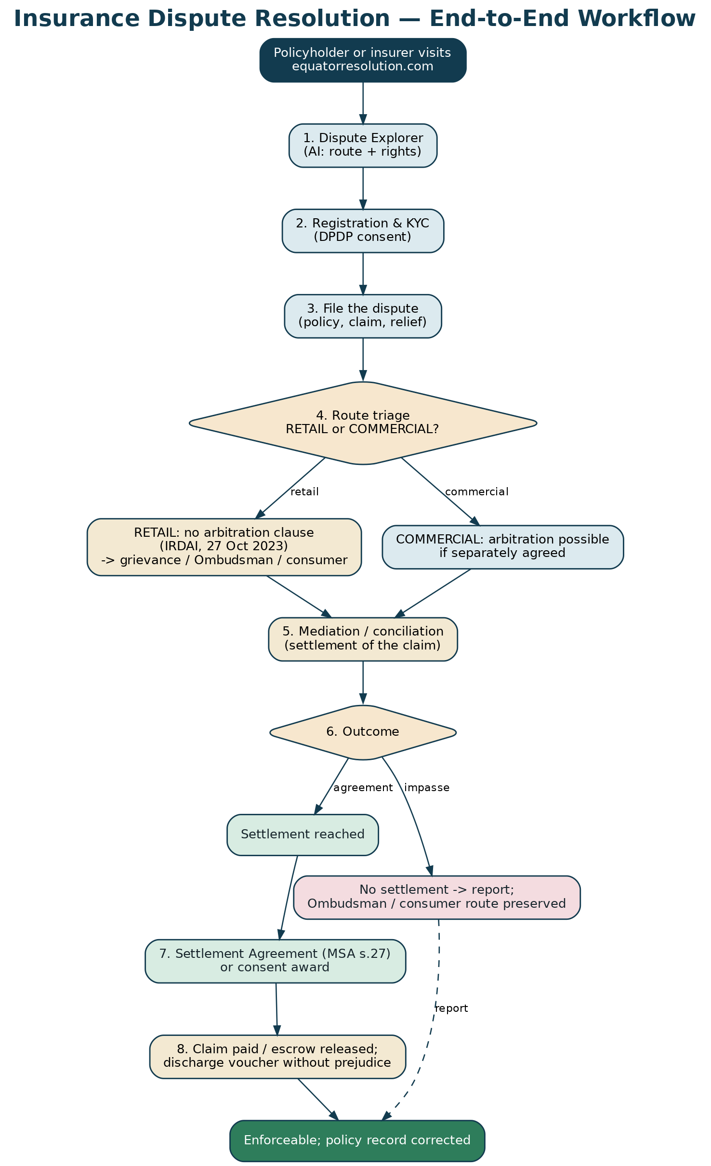
Figure C-1: The end-to-end workflow, from explorer to enforceable settlement.
17. C2. Choosing between them — the decision rules
17.1 C2.1 For an individual policyholder
- Always complain to the insurer in writing first, and register on Bima Bharosa the same day. Nothing else is possible until this is done, and it costs nothing. (Form F-I04.)
- Wait 30 days, or until an unsatisfactory reply arrives, whichever is sooner.
- If the claim is within ₹50 lakh, the Insurance Ombudsman is ordinarily the right forum: free, no lawyer, and the award binds the insurer up to ₹30 lakh but not the complainant. File within one year.
- Mediate in parallel where the insurer is willing, where a non-monetary outcome matters (policy reinstatement, withdrawal of an adverse remark, conversion of a mis-sold product), or where speed matters more than vindication.
- Go to the consumer commission where the claim exceeds ₹50 lakh, where the Ombudsman window has closed, or where compensation beyond the claim is sought — remembering that once filed, the Ombudsman route closes.

17.2 C2.2 For a commercial insured
- The Ombudsman is not available — it is a scheme for individual policyholders.
- Mediate first. It is faster and cheaper than anything else on the list, and quantum disputes settle.
- Arbitrate only if a separate arbitration agreement exists or the parties make one now. Weigh the section 29A timetable and the cost against a consumer or civil claim.
- Consider the consumer route where the entity qualifies as a consumer and the value fits — this is fact-specific and is a question for the party's own advisers, not for Equator.

17.3 C2.3 For an insurer
- Where the claim decision is weak, an early mediated settlement costs less than an award plus interest plus the regulatory complaint metric.
- Where the decision is sound but the relationship matters, mediation offers non-monetary outcomes that an award cannot construct.
- Where fraud is genuinely alleged, do not mediate the claim — investigate, and mediate only the consequences if both sides want that.
- Where a book of small disputes has accumulated, a batched mediation protocol resolves them at a fraction of the per-case cost of contesting each one.

18. C3. The clocks
Every insurance matter carries several clocks running simultaneously. Equator's obligation is to know them, tell the party, and never let one expire because a mediation was running.
Clock | Runs from | Period | Consequence of expiry
Insurer's reply window | Written representation to the insurer | 30 days | The Ombudsman route opens; nothing is lost
Ombudsman filing window | The insurer's reply, or expiry of the 30-day period | 1 year | The Ombudsman route closes permanently
Consumer limitation | The cause of action | Ordinarily 2 years | The consumer complaint becomes time-barred, subject to condonation
Policy suit-time-bar condition | Repudiation, per the policy wording | Varies — often 12 months | The insurer will take the point; its enforceability is contestable [verify]
Section 29A arbitral clock | Completion of pleadings | 12 months, extendable by 6 | The tribunal's mandate terminates absent extension
Mediation timetable (Mediation Act, 2023) | Commencement of mediation | As prescribed | Mediation concludes; other routes continue [verify — current period]

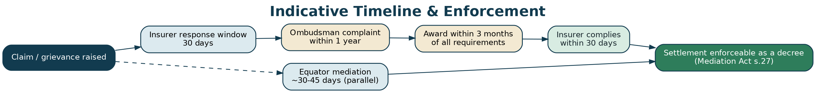
Figure C-2: Indicative timeline and enforcement.
COMPLIANCE NOTE
Control IN-C-02: the case record stores a clock table with a trigger date, period, expiry date and owner for every applicable clock. The system raises an alert to the case manager at 90, 60 and 30 days before any expiry, and blocks case closure if any clock is unowned. This is the vertical's most important operational control.

19. C4. What Equator says at intake — the signposting script
STANDING SIGNPOSTING SCRIPT
“Before we go any further, three things you should know. First, there is a free government forum for insurance complaints — the Insurance Ombudsman. There are 17 offices, you don't need a lawyer, it costs nothing, and if it makes an award the insurer has to comply up to ₹30 lakh, while you remain free to go elsewhere if you're not satisfied. Second, to use it you must first complain to your insurer in writing and give them 30 days, and you must go to the Ombudsman within one year — I will give you that date in writing today. Third, what we do here is different: we try to get the two sides to agree, quickly, and we can agree things an award can't — reinstating your policy, removing a black mark, changing a product. Using us does not stop you using the Ombudsman. But it also doesn't pause your one-year clock, so we'll keep an eye on that date together.”

PRACTICAL SUMMARY
This script is not marketing copy that can be softened. It is delivered verbatim at first contact, is reproduced on the intake screen, is included in the confirmation email, and its delivery is recorded on the case file. Quality assurance samples call recordings against it. A case manager who does not deliver it has committed a process breach.

PART D
The Equator Process — Design of the Insurance Vertical
20. D1. The nine stages
# | Stage | What happens | Owner | Target | Form
1 | Explore | The AI Dispute Explorer classifies the dispute, names the forums, states the clocks, and hands off to a human | AI + case manager | Same day | —
2 | Register | Account, KYC, DPDP consent including express health-data consent | Party | Same day | F-I01
3 | File | The dispute, the policy, the claim, the insurer's stated grounds, the relief sought | Party | 1–2 days | F-I02, F-I05
4 | Triage | Retail or commercial; Ombudsman eligibility; clock table; suitability; signposting delivered and recorded | Case manager + reviewer | 2 working days | F-I13
5 | Notify & collect | Notice to the other party; production of the claim file, survey report and wording | Case manager | 14 days | F-I03, F-I06
6 | Prepare | Ground-by-ground schedule; line-item deduction table; the four tests; quantum range | Case manager | 3–5 days | F-I05, F-I09–F-I12
7 | Mediate | Joint session, then caucus; authority confirmed in advance | Neutral | 1–3 sessions | F-I14, F-I15
8 | Settle & pay | Settlement agreement; discharge voucher; escrow where staged; registration | Neutral + case manager | 7 days | F-I16, F-I17, F-I18
9 | Close & assure | Compliance verified; signposting re-issued if unsettled; feedback; retention class set | Case manager | On performance | F-I19, F-I20

21. D2. Stage 4 in detail — triage is the product
In the other verticals, triage is a routing step. Here it is the substantive service. A correctly triaged insurance dispute is already half resolved, because most insurance disputes fail on process.
21.1 D2.1 The five triage questions
- Retail or commercial? This determines whether arbitration is even available and which forums are open. It is a mandatory, un-skippable field, and it is checked by a reviewer.
- Is the Ombudsman available? Five conditions, all of which must hold: a written representation to the insurer; rejection, no reply in 30 days, or an unsatisfactory reply; within one year; claim within ₹50 lakh; and not pending before or decided by a court, commission or arbitrator. If any fails, the fallback route is recorded in the same breath.
- What are the clocks, and when do they expire? Every applicable clock gets a trigger date, a period, an expiry date and a named owner. This table is printed for the party.
- Is the matter suitable for mediation at all? Fraud allegations requiring investigation, matters that are really criminal, and cases where one side has no authority to settle are all screened out — and screened out *with* a route, never with a shrug.
- Has the party been signposted, in writing, in a language they understand? Recorded as a discrete compliance event, not assumed.

21.2 D2.2 The screen-out rules
Situation | Action | Why
Third-party motor injury or death | Signpost to the Motor Accidents Claims Tribunal; mediate quantum only if the tribunal and both parties are content | The tribunal has exclusive statutory jurisdiction over the claim itself
Insurer alleges fabricated documents or a staged loss | Do not mediate the claim. Offer to mediate the consequences only if both sides expressly ask | Mediating an alleged fraud risks laundering it and exposes the institution
A consumer complaint or civil suit is already pending on the same subject-matter | Mediation may still proceed with the forum's leave or by referral, but the Ombudsman route is closed — say so | The statutory bar operates on the Ombudsman, not on mediation, but the party must know
The claim exceeds ₹50 lakh | Ombudsman unavailable; route to consumer commission, civil court, or arbitration if commercial and agreed | Monetary jurisdiction
The one-year Ombudsman window has closed | Say so plainly, and route to the consumer commission | Concealing this to keep a mediation alive would be a serious integrity failure
A vulnerable party — bereaved, seriously ill, elderly, no language in common | Safeguards: support person, interpreter, extra time, shuttle mediation, fee waiver | Capacity to negotiate is not the same as legal capacity
No settlement authority on the insurer's side | Do not convene. Reschedule with an authorised officer or a named approver on call | A session without authority wastes the policyholder's time and the mediator's credibility

22. D3. Stage 6 in detail — preparation is the leverage
Preparation is where the asymmetry described in Part A is corrected. Four artefacts are produced in every case, and their production is what changes the negotiation.
Artefact | What it is | Effect on the negotiation
Ground-by-ground schedule (F-I05 section B) | Each ground the insurer relies on, in its own row, with the clause cited, the policyholder's answer and the document that proves it | Forces the insurer to defend each ground separately. Grounds asserted loosely in a repudiation letter are commonly narrowed or withdrawn once itemised
Four-tests grid (F-I05 section C) | Materiality, proximate cause, contra proferentem, fair dealing — applied to each ground | Moves the discussion from “our decision stands” to “which test does this satisfy, and on what document?”
Line-item schedule (F-I09 / F-I10 / F-I12) | Every head of charge: billed, allowed, deducted, reason, answer | The single most effective document in the vertical. Double-counted and unsupported deductions become visible and are usually conceded without argument
Clock table (F-I13 step 3) | Every applicable limitation and filing deadline with its expiry date | Protects the party, and — because both sides can see it — creates honest, shared time pressure

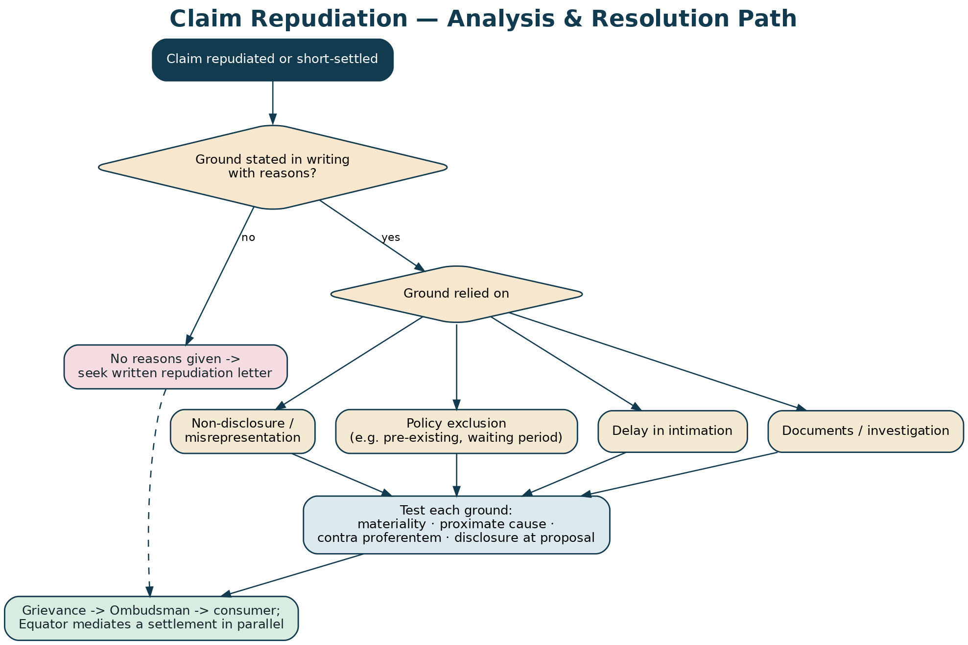
Figure D-1: Analysing a repudiation, ground by ground.
23. D4. Stage 7 in detail — how an insurance mediation actually runs
23.1 D4.1 Before the session
- Authority is confirmed in writing. Who can settle, up to what figure, and who approves above it, with a turnaround commitment. (Form F-I14 section 4.) Where a reinsurer or co-insurer must agree, that is flushed out now, not in the session.
- The claim file is on the table. Including the survey or investigation report. An insurer that will not produce the report it relied on is told that the neutral will note the fact.
- The policyholder has a realistic range, not a number — built from the line-item schedule, not from hope.
- Vulnerability safeguards are in place — interpreter, support person, shuttle format, session length.

23.2 D4.2 The session
- Opening. The neutral repeats that nothing said is admissible, that participation is not an admission of liability, and that the policyholder's Ombudsman and consumer rights are unaffected.
- The insurer states its grounds against the schedule — each one, with the clause and the document.
- The policyholder answers, ground by ground, against the same schedule.
- The line items are worked through, not the grand total. Insurance settles by narrowing, not by splitting.
- Caucus. Private sessions establish each side's real range and the non-monetary levers — continuity, adverse-remark withdrawal, a written correction, a payment date.
- Package, not price. The best insurance settlements are packages: a figure, plus reinstatement with continuity, plus removal of a flag, plus a date certain. The figure alone is usually the hardest part to move; the package is what closes.
- Document immediately. The terms are drafted, read back and signed before anyone leaves. An insurance settlement that goes away for internal drafting frequently does not come back.

THE NEUTRAL'S LINE THAT MUST NEVER BE CROSSED
The neutral does not say whether the claim is good, does not predict what the Ombudsman would award, and does not advise either party. The neutral asks questions: *which test does this ground satisfy? · on what document? · was that report shared? · what does that clause actually say? · what would it take?* The value comes from the structure of the questions, not from an opinion. This is drilled in the ECIN curriculum and is assessed in accreditation.

24. D5. Stage 8 — what an insurance settlement contains
- The money: amount, whether it includes interest, TDS treatment, the account, and a date.
- The policy: reinstated or continued from a stated date, with continuity of waiting periods and cumulative bonus preserved — this is frequently worth more to the policyholder than the cash.
- The record: any adverse remark, fraud flag or repudiation entry withdrawn from the insurer's records and, where applicable, from industry databases, in writing.
- The pending complaint: disposed of in terms of the settlement rather than merely withdrawn, wherever a complaint is pending before the Ombudsman or a commission. A disposal in terms converts the settlement into an order of that forum too, at no extra cost.
- The discharge: full and final for *this* claim under *this* policy — never for future events, and never purporting to waive a right that cannot be contracted away.
- Default: acceleration with interest, and enforcement as a decree under section 27 of the Mediation Act, 2023, without a further reference to mediation.

RISK / CAUTION
The discharge-voucher trap. Insurers routinely require a full-and-final discharge voucher before releasing payment, and a policyholder in financial need signs it. Where the amount is disputed, the voucher must be endorsed “under protest, balance reserved” — Form F-I17 makes this a tick-box so it cannot be overlooked. A voucher signed under protest or expressly without prejudice does not, by itself, bar a claim for the balance, and the position is stronger still where the signature was obtained under financial compulsion. [verify — current case law]

PART E
Dispute Taxonomy, Data Model & Product Design
25. E1. The taxonomy
Every option list in the platform derives from this taxonomy. It is reproduced in full in the Developer Handoff Workbook as enumerated types, and in the forms as checkbox lists.
25.1 E1.1 Level 1 — line of business
Group | Values
Life | Term · Endowment · Money-back · ULIP · Annuity / pension · Group life · Credit life
Health | Individual retail · Family floater · Group / employer · Senior citizen · Top-up / super top-up · Critical illness · Personal accident · Travel
Motor | Private car own damage · Two-wheeler · Commercial vehicle · Third party · Add-on covers
Property & commercial | Home / householder · Fire & special perils · Burglary · Marine cargo · Marine hull · Engineering / CAR / EAR · Business interruption
Liability & specialty | CGL · Product liability · Professional indemnity · D&O · Cyber · Credit / trade credit · Title
Rural & government | Crop / PMFBY · Cattle · Government-sponsored health schemes

25.2 E1.2 Level 2 — dispute type
Twenty-five values, exactly as they appear on Form F-I02: claim repudiated in full · short-settled · cashless denied · delay in settlement · delay in intimation alleged · non-disclosure alleged · PED or waiting period applied · policy exclusion applied · sum insured or IDV dispute · room-rent or proportionate deduction · co-pay or sub-limit · depreciation, salvage or excess · underinsurance or average · survey report disputed · mis-selling · free-look refund refused · premium, renewal or lapse · policy or documents not served · nomination or assignment · portability refused · surrender value or bonus · cancellation by insurer · recovery or subrogation · broker or agent conduct · other.
25.3 E1.3 Level 3 — ground relied on by the insurer
Fifteen values: non-disclosure of a material fact · misrepresentation or fraud (s.45) · pre-existing disease · waiting period · specific exclusion · delay in intimation · policy lapsed · outside the policy period · documents not furnished · adverse investigation · not a covered peril / proximate cause · breach of condition or warranty · limit exhausted · duplicate or inflated claim · other.
25.4 E1.4 Level 4 — relief sought
Fifteen values, monetary and non-monetary, as set out on Form F-I02 section 7 — including the four that an Ombudsman award cannot easily deliver: policy conversion or substitution, reinstatement with continuity, removal of an adverse remark or fraud flag, and correction of records. Those four are flagged in the product as “mediation-only outcomes” because they are the vertical's differentiator.
26. E2. The routing matrix
The AI Dispute Explorer and the case-manager console both drive off this matrix. It is deterministic: the model classifies, the matrix routes. The model does not decide the route.
If… | Then the routes are… | And the mandatory disclosure is…
Retail + claim ≤ ₹50 lakh + within 1 year + representation made | Insurance Ombudsman (primary) · Equator mediation (parallel) · consumer commission (alternative) | The Ombudsman is free, needs no lawyer, and binds the insurer up to ₹30 lakh
Retail + no written representation yet | Insurer grievance cell first (F-I04) + Bima Bharosa; then re-triage | Nothing else is possible until this is done
Retail + more than 1 year since the insurer's reply | Consumer commission · civil court · Equator mediation | The Ombudsman route has closed — stated plainly and in writing
Retail + claim > ₹50 lakh | Consumer commission (by value tier) · civil court · Equator mediation | The Ombudsman's monetary jurisdiction is exceeded
Retail + a legacy arbitration clause in the policy | Ignore the clause for routing. Ombudsman · consumer · court · mediation | Retail policies are not to carry arbitration clauses (IRDAI, 27 October 2023), and the consumer remedy cannot be ousted
Commercial + separate arbitration agreement exists | Mediation first · arbitration | The Ombudsman is not available to commercial insureds
Commercial + no arbitration agreement | Mediation · civil court · arbitration only if the parties now agree separately | Same
Third-party motor injury or death | Motor Accidents Claims Tribunal | Neither the Ombudsman nor the consumer commission decides this
Fraud alleged by the insurer | Investigation or litigation; mediation of consequences only by express joint request | Equator does not mediate an alleged fraud

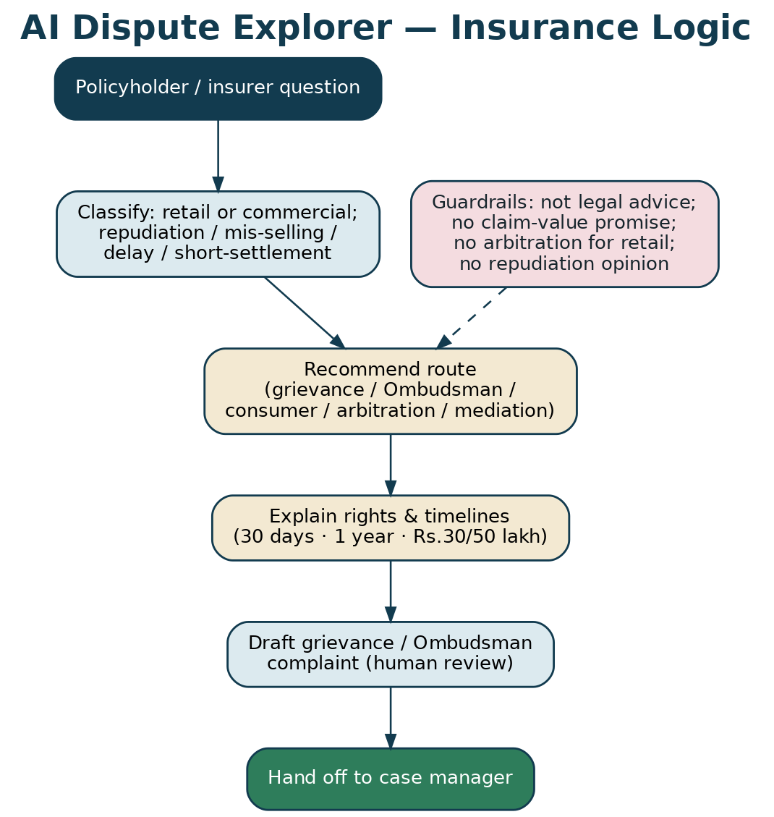
Figure E-1: AI Dispute Explorer logic and guardrails.
27. E3. Data model — the entities that matter
Entity | Key fields | Constraint that must be enforced in the database
policy | insurer, policy_no, line, plan, inception_date, first_ever_inception_date, period, sum_insured, premium, intermediary, is_retail | `is_retail` is NOT NULL — no policy record may exist without a retail/commercial classification
claim | claim_no, loss_date, intimation_date, amount_claimed, amount_offered, amount_paid, decision_date, decision_type | amount_offered ≤ amount_claimed; decision_date ≥ intimation_date
dispute_case | case_no, policy_id, claim_id, dispute_types[], grounds[], relief[], route, status | `CHECK (route <> 'arbitration' OR policy.is_retail = false)` — the retail-arbitration bar, enforced as a constraint, not as a policy
clock | case_id, clock_type, trigger_date, period_days, expiry_date, owner | expiry_date is generated, not entered; a case cannot be closed while a clock has no owner
signposting_event | case_id, delivered_at, channel, language, script_version, delivered_by | At least one row is required before a case may leave triage
deduction_line | claim_id, head, billed, allowed, deducted, reason_code, response | billed = allowed + deducted; a reason_code is mandatory on any non-zero deduction
settlement | case_id, amount, interest, tds, continuity_preserved, adverse_remark_withdrawn, registered_at, enforceable_s27 | `CHECK (statutory_rights_waived = false)` — no settlement may recite a waiver of a non-waivable right
health_record_ref | case_id, source, classification, access_log_id | Separate table, encrypted, field-level access control, excluded from every analytics and AI dataset

COMPLIANCE NOTE
Three constraints are institutional, not technical, and must be implemented as database CHECK constraints so that no code path can bypass them: (1) no arbitration route on a retail policy; (2) no settlement asserting a waiver of a non-waivable statutory right; (3) no case closure without a delivered signposting event and a fully owned clock table. These mirror the three rules proven in the platform Reference Implementation.

28. E4. The AI Dispute Explorer — scope and guardrails
The explorer classifies, routes, explains and drafts. It does not advise, predict or decide.
It may… | It must never…
Classify the line of business, dispute type and ground | Say whether the claim will succeed, or estimate what it is worth
Determine retail or commercial and route accordingly | Suggest arbitration for a retail policy, in any phrasing, ever
State the applicable clocks and compute expiry dates | Imply that mediation pauses or extends a limitation period
Explain the Ombudsman, its limits and how to file | Suggest that using Equator replaces or forecloses the Ombudsman
Draft a grievance letter or an Ombudsman complaint for human review | File anything, or send anything, without a human in the loop
Summarise the policy wording the party has uploaded | Interpret an ambiguous clause as though it were settled law
Hand off to a case manager at any point | Continue when the party is distressed, bereaved or asking for legal advice

Each “must never” has a numbered guardrail (IN-G-01 to IN-G-12) with at least two adversarial test cases in the evaluation harness. A guardrail without a failing-and-then-passing test case is not a guardrail.

PART F
Operations, Neutrals & Economics
29. F1. The panel
An insurance panel needs a different blend from the other verticals: technical claims knowledge sits alongside mediation skill, and the independence risk is sharper because one side is a repeat player.
Profile | What they bring | Target mix | Independence caution
Retired insurance company officers (claims, legal) | Knows how a claim file is actually built and what an insurer can concede | 25% | Cooling-off from their former employer; disclosed appointment counts
Former Insurance Ombudsman staff or deputies | Knows the statutory forum's reasoning and standards | 10% | Must not create the impression that Equator is an arm of the Ombudsman
Licensed surveyors and loss assessors (accredited as mediators) | Credibility on quantum in motor, fire, marine and engineering | 20% | Must not have surveyed the loss in question, or for that insurer within the cooling-off period
Medical professionals (accredited) | Health claims — medical necessity, PED, day-care | 10% | No treating relationship with the claimant; no panel role with the insurer
Lawyers with insurance practice | Coverage disputes, section 45, commercial wordings | 20% | Must not act for either party in a related matter afterwards
Consumer-side advocates and financial counsellors | Balance; credibility with policyholders | 15% | Must not carry a case for the policyholder into the mediation

RISK / CAUTION
Repeat-player capture is the defining integrity risk of this vertical. An insurer that supplies a large share of a neutral's appointments is, in effect, that neutral's client. Controls: mandatory disclosure of appointment counts by insurer (Form F-I15 section B); a cap on the proportion of a neutral's Equator appointments attributable to a single insurer; rotation; a cooling-off period after employment by an insurer; publication of aggregate outcome statistics by insurer; and a standing instruction that no neutral is ever selected by the insurer alone.

30. F2. Accreditation — the ECIN curriculum
The Equator Certified Insurance Neutral (ECIN) programme is set out in full in the training curriculum companion. In outline:
Module | Hours | Content | Assessment
1. The forum map | 6 | Ombudsman Rules, Bima Bharosa, consumer commissions, MACT, arbitration; the retail/commercial split | Routing exercise, 20 fact patterns
2. Insurance law essentials | 10 | Section 45; materiality; proximate cause; contra proferentem; condition breach and nexus | Written paper
3. Reading a claim file | 8 | Proposal form, policy schedule and wordings, survey report, investigation report, medical records | Practical file exercise
4. Health claims | 8 | PED, waiting periods, portability, room-rent proportionality, sub-limits, cashless | Line-item schedule built from a real bill
5. Motor claims | 6 | IDV, depreciation, salvage, total loss, non-standard settlement | Case study
6. Life claims | 6 | Early claims, section 45 arithmetic, nomination and heirship | Case study
7. Commercial lines | 8 | Survey, underinsurance and average, business interruption, co-insurance | Case study
8. Mis-selling | 4 | Free-look, benefit illustration, bancassurance patterns, remedies beyond refund | Drafting exercise
9. Mediation skill | 16 | Structure, caucus, packaging, impasse, drafting | Observed role-play, twice
10. Ethics, independence and the vulnerable party | 8 | Repeat-player capture; the bereaved and seriously ill claimant; the line the neutral must not cross | Scenario assessment
11. Data protection and health data | 4 | DPDP obligations; handling medical records | Test
Supervised practice | 3 cases | Co-mediation with an accredited neutral | Supervisor sign-off

31. F3. Unit economics
The financial model workbook carries the live figures and scenarios. The design assumptions are:
Segment | Fee basis | Cost to serve | Notes
Retail policyholder, self-filed | Low flat filing fee, with a waiver policy | Case-manager time dominates | Loss-leading by design; the volume justifies the insurer-side sale
Retail, insurer-referred under a protocol | Per-case fee borne by the insurer | Lower — the claim file arrives complete | The core recurring revenue line
Insurer subscription | Annual, tiered by grievance volume | Account management + reporting | Includes the protocol, reporting pack and batched-settlement days
Batched settlement day | Day rate plus per-case | One neutral, one venue, many small claims | The highest-margin product in the vertical, and the one insurers buy most readily
MSME / commercial | Ad valorem tariff on the amount in dispute | Neutral fee dominates | Priced against arbitration, not against the Ombudsman
Broker-referred | Standard tariff; no fee sharing | Standard | Fee sharing with a referrer would compromise neutrality and is prohibited

PRACTICAL SUMMARY
The batched settlement day is the commercial insight of this vertical. An insurer with 400 small contested health claims cannot economically litigate them and does not want 400 Ombudsman complaints. One neutral, one day, thirty files, a standing settlement grid agreed in advance, and thirty decree-grade settlements at the end of it. Nothing in the statutory system offers this.

32. F4. Service standards
Standard | Target | Measured how
Signposting delivered at first contact | 100% | Recorded event on the case file; call sampling
Triage completed | 2 working days | System timestamp
Clock table complete and owned | 100% before leaving triage | System block
Notice issued to the other party | 3 working days from triage | System timestamp
Claim file produced by the insurer | 14 days | Tracked; non-production noted in the file
First session convened | 21 days from response | System timestamp
Settlement drafted and signed | Same day as agreement | Document timestamp
Payment received | Per the agreed date; verified | Escrow / confirmation on file
Case closed with compliance verified | 7 days from performance | F-I20 completion
Party feedback captured | ≥ 70% of closed cases | Feedback log

PART G
Risk, Compliance & Ethics
33. G1. The risk register — top ten
# | Risk | Impact | Control | Owner
1 | A retail policyholder is routed into arbitration | Severe — regulatory and reputational | Mandatory classification; reviewer sign-off; database CHECK constraint; AI guardrail with tested cases | Head of Legal
2 | A one-year Ombudsman window closes during a mediation | Severe — direct harm to the party | Clock table with named owners; alerts at 90/60/30 days; mandatory prompt to file at 60 days; closure block | Head of Operations
3 | Equator is perceived as, or presents itself as, an official forum | Severe — regulatory | Standing signposting script; brand rules; AI guardrail; marketing review | Head of Legal
4 | Repeat-player capture of a neutral | High — integrity of every outcome | Appointment-count disclosure and caps; rotation; cooling-off; published aggregate outcomes | Head of Panel
5 | Health-data breach or misuse | Severe — DPDP and human | Separate encrypted store; field-level access control; access logging and monthly review; exclusion from all analytics and AI datasets; vertical-specific DPIA | DPO
6 | A settlement purports to waive a non-waivable right | High — unenforceable and unethical | Template control; database CHECK constraint; neutral training; QA sample | Head of Legal
7 | A discharge voucher is signed under compulsion without reservation | High — the party loses the balance | Form F-I17 tick-box; case-manager script; QA sample | Head of Operations
8 | A fraud allegation is mediated | High — institutional exposure | Screen-out rule at triage; neutral's standing instruction; escalation to Head of Legal | Head of Legal
9 | The AI explorer gives merits or valuation advice | High — regulatory and reliance | Guardrails IN-G-01 to IN-G-12; adversarial evaluation harness run before every release; human handoff path | Head of Technology
10 | Insurer non-performance of a settlement | Medium — but corrosive | Escrow or milestone structure; acceleration clause; registration under s.27; performance tracked to closure | Head of Operations

34. G2. The ethical commitments
- We tell every policyholder about the free forum, first, every time. Not in a footnote.
- We never let a clock run out on our watch. If we cannot settle in time, we tell the party to file and we record that we did.
- We do not advise on the merits and we do not price the claim. Neither does our software.
- We do not sell arbitration to retail policyholders. Not as a product, not as a suggestion, not as an aside.
- We do not take a share of the settlement in a way that gives us an interest in the number. Our fee does not depend on the policyholder accepting less.
- We publish our outcomes by insurer in aggregate. An institution that will not show its own numbers cannot ask a policyholder to trust it.
- We handle health data as though it were our own family's. Because in this vertical, one day, it will be.

PART H
Annexures
35. Annexure A — Legal authorities and sources
Instrument / source | Relevance | Status as at July 2026
Insurance Act, 1938 — s.45 | Limits on calling a life policy in question | In force; text as amended [verify — applicable period]
Sabka Bima Sabki Raksha (Amendment of Insurance Laws) Act, 2025 | Up to 100% FDI in insurance; amendments to the insurance laws | Passed by Parliament 16–17 December 2025; Presidential assent 20 December 2025 [verify — provisions brought into force]
Insurance Ombudsman Rules, 2017 (amended 2021; further amended thereafter) | The statutory forum: 17 centres, ₹50 lakh jurisdiction, ₹30 lakh binding award, 1-year limit, 30-day compliance | In force [verify — current limits and centre list]
IRDAI circular dated 27 October 2023 — Amendment of Arbitration Clause in General Insurance Policies | No arbitration clause in retail policies; separate agreement permitted for commercial | In force
Delhi High Court decision upholding a separately agreed arbitration provision (December 2025) | Confirms the binding character of a commercial arbitration agreement post-circular | [verify — citation and any appeal]
IRDAI (Protection of Policyholders' Interests, Operations and Allied Matters of Insurers) Regulations, 2024 | Policy servicing, claim turnaround, grievance machinery, point-of-sale conduct | In force
Draft IRDAI (Internal Insurance Ombudsman) Guidelines, 2025 | Proposed mandatory internal ombudsman; ₹50 lakh; reasoned decision typically within 15 days | Issued 23 July 2025; consultation closed 17 August 2025 [verify — finalisation and commencement]
Bima Bharosa (IRDAI grievance system) | Registration, routing and escalation of grievances | Live; replaced IGMS in 2023
Bima Sugam | Insurance electronic marketplace | Notified March 2024; Phase 1 live December 2025 [verify — current scope]
Consumer Protection Act, 2019 | Consumer commissions; independent statutory remedy | In force [verify — current pecuniary limits]
Mediation Act, 2023 — s.27 | Mediated settlement enforceable as a decree | In force
Arbitration & Conciliation Act, 1996 — ss.12, 29A, 31, 34, 36 | Disclosure, timetable, award, challenge, enforcement | In force
Digital Personal Data Protection Act, 2023 and Rules | Consent, purpose limitation, health data | In force; phased [verify — applicable phase]
Council for Insurance Ombudsmen, Annual Report 2023-24 | 52,575 complaints received; 49,705 disposed; 12,855 non-entertainable; 15,528 recommendations; 9,287 awards for complainants; 8,638 for insurers; disposal up over 43% | Published
IRDAI Annual Report 2023-24 | 2,15,569 Bima Bharosa grievances, of which 1,20,726 life | Published [verify — latest edition]

36. Annexure B — The intake checklist
Printed on the case-manager console and completed on every matter without exception.
# | Check | Evidence
1 | Signposting script delivered, in a language the party understands | Recorded event; call sample
2 | Retail or commercial classified, and reviewed | F-I13 step 1 + reviewer initials
3 | Ombudsman eligibility assessed against all five conditions | F-I13 step 2
4 | Written representation to the insurer made — or Form F-I04 issued | Copy on file
5 | Bima Bharosa token obtained | Token on the case record
6 | Clock table complete, with an owner for each clock | F-I13 step 3
7 | Last date to file with the Ombudsman given to the party in writing | Email on file
8 | DPDP consent recorded, including the separate health-data consent | F-I01
9 | Vulnerability assessed and safeguards recorded | F-I13 step 4
10 | Suitability assessed; screen-out rules applied | F-I13 step 4
11 | Claim file, survey or investigation report, and wording requested | F-I03 / F-I06
12 | Settlement authority confirmed on the insurer's side before any session | F-I14 section 4

37. Annexure C — Worked examples
37.1 C-1 Health: the deduction stack
A ₹4.8 lakh cardiac admission. Cashless denied for PED; reimbursement paid at ₹1.1 lakh. The line-item schedule shows five deductions: PED disallowance, room-rent proportionality applied across all heads, co-pay, consumables, and a package-rate cap. Preparation establishes that the policy has run continuously since 2019, so the 36-month PED waiting period was complete; that proportionality has been applied to surgeon's fees and the implant, which do not vary with room category; and that co-pay has been applied after, as well as before, the proportionate reduction. Three of the five deductions fall away on the documents alone. The settlement lands at ₹3.9 lakh plus reinstatement with continuity, in one session. *(Illustrative composite; not a real case.)*
37.2 C-2 Life: the section 45 arithmetic
An early death claim repudiated for non-disclosure of hypertension. The dispute appears to be medical. It is not: the policy was revived eleven months before the death, which resets the clock, so the insurer is inside the section 45 window and may raise the ground — but the repudiation letter did not enclose the materials relied on, as the section requires. Once that is put on the table, the insurer offers a negotiated settlement rather than defend the procedure before the Ombudsman. *(Illustrative composite.)*
37.3 C-3 Motor: the technical breach
An own-damage claim repudiated because the driver's licence had expired eight days before the accident. There is no suggestion the expiry contributed to the collision. The neutral asks the insurer to identify the nexus between the breach and the loss. There is none. The matter settles on the established non-standard basis — a percentage of the assessed loss — in forty minutes. *(Illustrative composite.)*
37.4 C-4 Commercial: underinsurance
A fire claim of ₹2.4 crore reduced by 38% for underinsurance. The sum insured was set by the broker at renewal on a book-value basis while the wording provides for reinstatement value. The broker joins the mediation. The insurer accepts a lower underinsurance percentage; the broker contributes; the insured accepts a reduction smaller than it feared and larger than it wanted. No arbitration, no two years. *(Illustrative composite.)*
37.5 C-5 Mis-selling: the bancassurance sale
A ₹5 lakh single payment made at a bank branch, understood by the customer to be a five-year deposit; the policy is a ten-year premium-paying endowment. The free-look has long expired. The evidence is the benefit illustration — unsigned — and the customer's statement showing the debit described as a deposit. The mediated outcome is conversion to a paid-up policy with no further premiums and a partial refund; neither a court nor an Ombudsman award would readily have constructed it. *(Illustrative composite.)*

38. Annexure D — Model clauses
38.1 D-1 Commercial-lines separate arbitration agreement
For use only where both parties are commercial and both agree. Never for a retail policy.
MODEL CLAUSE — COMMERCIAL ARBITRATION AGREEMENT
“The parties, both being commercial entities, hereby enter into this separate agreement, by mutual consent, that any and all disputes arising out of or in connection with policy no. ______, including any question regarding its existence, validity, interpretation, breach or termination, shall be referred to and finally resolved by arbitration administered by Equator Resolution under its Rules of Arbitration, which are deemed incorporated. The seat and venue shall be ______; the language shall be English; the tribunal shall consist of ______ arbitrator(s) appointed in accordance with those Rules. This agreement is entered into separately from, and in addition to, the policy, in accordance with the IRDAI circular dated 27 October 2023. Before commencing arbitration the parties shall attempt mediation under the Equator Insurance Mediation Rules for a period of 30 days, which shall not prejudice either party's position.”

38.2 D-2 Retail-policy mediation clause
MODEL CLAUSE — RETAIL MEDIATION (no arbitration)
“Any dispute arising under this policy may, at the option of the policyholder, be referred to mediation administered by Equator Resolution under its Insurance Mediation Rules. This clause does not, and shall not be construed to, affect, limit or replace the policyholder's rights to approach the insurer's grievance redressal officer, the Insurance Ombudsman, the Insurance Regulatory and Development Authority of India, a consumer commission or a civil court. Nothing in this policy requires the policyholder to arbitrate.”

38.3 D-3 Without-prejudice discharge endorsement
To be written above the signature on any discharge voucher for an amount the claimant disputes:
*“Received ₹______ on account and under protest. I expressly reserve my right to claim the balance of ₹______ and to pursue all remedies available to me, including before the Insurance Ombudsman, a consumer commission or a court. This receipt is not in full and final satisfaction of my claim.”*
38.4 D-4 Continuity-preservation term for a settlement
*“The policy shall stand reinstated with effect from ______ with full continuity of all waiting periods, the pre-existing-disease waiting period and cumulative bonus as though it had never been repudiated or cancelled. The insurer shall within 15 days issue a written confirmation to that effect and shall withdraw any adverse remark, repudiation entry or fraud indicator recorded against the policyholder in its own records and in any industry database to which it has reported the same, and shall confirm the withdrawal in writing.”*
38.5 D-5 Disposal-in-terms request where a complaint is pending
*“The parties having settled this matter, they jointly request that the complaint bearing no. ______ pending before ______ be disposed of in terms of the annexed settlement, rather than withdrawn, so that the settlement stands recorded as an order of this forum.”*
38.6 D-6 Insurer institutional protocol — core undertaking
*“The insurer undertakes to: (a) nominate a single point of contact and an officer with settlement authority of not less than ₹______; (b) produce the claim file, the policy wording and any survey or investigation report relied upon within 14 days of notice; (c) respond to a mediation notice within 14 days; (d) not require any discharge voucher inconsistent with the terms of a signed settlement; and (e) permit Equator to publish aggregate, anonymised outcome statistics for matters involving the insurer.”*

PART I
The Forms (Full Text)
This Part reproduces every Equator insurance form in full (F-I01 to F-I26), ready to lift into the platform or to use directly. The same set is delivered as individual Word documents in the Forms Pack folder. Forms F-I21 to F-I26 are the line-specific claim schedules — life/ULIP, marine & transit, liability, crop & rural, government health scheme, and cyber & business interruption.
Three of these forms exist to protect the policyholder rather than to serve the process, and must never be treated as optional: F-I04 (the written grievance to the insurer, without which the Insurance Ombudsman route never opens); F-I13 (the triage record, which fixes the retail/commercial classification and the clock table); and F-I19 (the signposting report, which tells a party who has not settled exactly where to go and by when).

Onboarding, KYC & Data-Protection Consent (Insurance) | Form F-I01
Create your account, verify identity, and record your consent under the DPDP Act, 2023.
A. PARTY DETAILS

Full name
Role (Policyholder / Claimant / Nominee / Legal heir / Insurer / Intermediary)
Policy number
Claim number (if allotted)
Insurer / company name
PAN / Aadhaar (masked — last 4 digits only)
Address
District & State
Mobile
Email
Authorised representative / advocate (if any)

B. YOUR ROLE

I am the:
☐ Policyholder (the insured) | ☐ Claimant / beneficiary
☐ Nominee | ☐ Legal heir / assignee
☐ Insurer / TPA | ☐ Agent / broker / intermediary
☐ Group policy master policyholder (employer / bank) | ☐ Authorised representative

C. IDENTITY VERIFICATION (KYC)

Identity is verified by Aadhaar-based e-KYC / OTP, or by upload of a government photo ID with a liveness check. Corporate parties upload a board authority or letter of authority. Nominees and legal heirs additionally upload proof of relationship or a succession document.
Verification method:
☐ Aadhaar e-KYC / OTP completed
☐ Government photo ID uploaded
☐ Corporate authority letter uploaded
☐ Proof of nomination / heirship uploaded
☐ Video verification (NRI) completed

D. DATA-PROTECTION NOTICE & CONSENT (DPDP Act, 2023)

Purpose: your personal data is processed solely to administer this insurance dispute — case management, communication with the insurer and any intermediary, neutral matching, drafting of a settlement, escrow or payment of any settled amount, and statutory compliance. Data categories: identity and contact details, policy and claim data, financial details, and — where the claim is a health or life claim — health data, which is treated as sensitive and is access-controlled on a strict need-to-know basis. Retention: only for as long as the purpose and law require, then securely erased. Your rights: access, correction, erasure, withdrawal of consent, nomination and grievance redress.
DECLARATION & UNDERTAKING

☐ I give my free, specific, informed and withdrawable consent to Equator Resolution processing my personal data, including health data where the claim requires it, for the stated purposes.
☐ I authorise Equator to seek and receive the claim file, survey report and medical records from the insurer, TPA, hospital or surveyor for this dispute only.
☐ Where any information relates to a deceased life assured or a minor, I confirm I am the lawful nominee, heir or guardian entitled to act.
☐ The information provided is true and correct to the best of my knowledge.

________________________  Party  Name / Signature / Date | ________________________  Verified by (Equator)  Name / Signature / Date

Grievance / Data Protection Officer: grievance@equatorresolution.com. Equator Resolution acts as a Data Fiduciary under the DPDP Act, 2023. Health data is stored encrypted and is visible only to the case manager and the neutral assigned to the matter.

Request for Resolution (Insurance Dispute) | Form F-I02
Commences an insurance dispute at Equator. May be filed by a policyholder, claimant, nominee or by an insurer.
Case No. (office use)
Date of filing

1. THE POLICY

Insurer / company
Policy number
Policy type & plan name
Date of commencement
Policy period (from – to)
Sum insured / sum assured (₹)
Annual premium (₹)
Premium paid up to
Intermediary — agent / broker / bancassurance
Was the policy sold online, by phone, at a branch or by an agent?

Line of business:
☐ Life — term / endowment / money-back | ☐ Life — ULIP
☐ Life — annuity / pension | ☐ Health — individual (retail)
☐ Health — family floater (retail) | ☐ Health — group / employer
☐ Personal accident | ☐ Critical illness
☐ Travel | ☐ Motor — own damage (private car)
☐ Motor — own damage (commercial vehicle) | ☐ Motor — third party
☐ Home / householder | ☐ Fire & special perils (commercial)
☐ Marine cargo | ☐ Marine hull
☐ Engineering / CAR / EAR | ☐ Liability — CGL / product / professional indemnity
☐ Directors' & officers' (D&O) | ☐ Credit / trade credit
☐ Crop / PMFBY | ☐ Title insurance
☐ Other

2. RETAIL OR COMMERCIAL (this determines your route)

This policy is:
☐ **Retail / individual** — a policy taken by an individual or family for personal cover
☐ **Commercial** — a policy taken by a company, firm, LLP or other business for its business risks
☐ Group policy (employer / bank / association is the master policyholder)
☐ Not sure — please assess

Why this matters. By an IRDAI circular dated 27 October 2023, retail general-insurance policies must not contain an arbitration clause; disputes go to the insurer's grievance cell, the Insurance Ombudsman, the consumer commission or a civil court. Commercial policies may contain no arbitration clause in the policy either, but the parties may enter a separate, mutually agreed arbitration agreement for any and all disputes. A consumer's right to approach the consumer commission is an independent statutory remedy and cannot be taken away by any arbitration clause.

3. THE CLAIM

Date of loss / event / hospitalisation / death
Date claim intimated to insurer
Claim number
Amount claimed (₹)
Amount offered or paid by insurer (₹)
Amount in dispute (₹)
Date of repudiation / short-settlement letter
Has a discharge voucher been signed? (Y / N / under protest)

Nature of the dispute:
☐ Claim repudiated (rejected in full) | ☐ Claim short-settled / partial payment
☐ Cashless authorisation denied | ☐ Delay in settlement
☐ Delay in claim intimation alleged by insurer | ☐ Non-disclosure / misrepresentation alleged
☐ Pre-existing disease / waiting period applied | ☐ Policy exclusion applied
☐ Sum insured / IDV dispute | ☐ Deduction — room-rent capping / proportionate
☐ Deduction — co-pay / sub-limit | ☐ Deduction — depreciation / salvage / excess
☐ Underinsurance / average clause applied | ☐ Survey / loss-assessor report disputed
☐ Mis-selling at point of sale | ☐ Free-look refund refused
☐ Premium / renewal / lapse dispute | ☐ Policy not issued / documents not served
☐ Nomination / assignment dispute | ☐ Portability / migration refused
☐ Surrender value / bonus dispute | ☐ Cancellation by insurer
☐ Recovery / subrogation dispute | ☐ Broker / agent conduct
☐ Other

4. WHAT THE INSURER SAID

Ground(s) relied on by the insurer (as stated in its letter):
☐ Non-disclosure of a material fact | ☐ Misrepresentation / fraud (s.45)
☐ Pre-existing disease not disclosed | ☐ Waiting period not completed
☐ Specific policy exclusion | ☐ Delay in intimation of claim
☐ Policy lapsed / premium unpaid | ☐ Claim outside the policy period
☐ Documents not furnished | ☐ Investigation adverse
☐ Not a covered peril / proximate cause not covered | ☐ Breach of policy condition / warranty
☐ Sum insured / limit exhausted | ☐ Duplicate or inflated claim alleged
☐ Other

Quote the insurer's stated reason, in its own words

5. YOUR ACCOUNT OF THE DISPUTE

Set out the facts and dates in not more than 400 words

Specimen: 'My mother was hospitalised on 12 March 2026 for a cardiac procedure. Cashless was denied the same day citing a pre-existing disease. The policy has been continuously in force since 2019, so the 36-month PED waiting period was complete. I paid ₹4,80,000 and filed for reimbursement. On 2 May 2026 the insurer paid ₹1,10,000 and deducted the rest for room-rent proportionality and PED. I complained to the grievance cell on 5 May 2026 and have had no substantive reply.'

6. PRE-FILING STEPS TAKEN

Complaint made to insurer's grievance cell on
Reply received on (or 'none')
Bima Bharosa / IGMS token number
Complaint to the Insurance Ombudsman? (date / centre)
Case filed in a consumer commission or court? (forum, number, stage)

7. RELIEF SOUGHT

Relief:
☐ Payment of the claim in full | ☐ Payment of the balance / disputed amount
☐ Reversal of a specific deduction | ☐ Cashless authorisation
☐ Interest for the period of delay | ☐ Refund of premium (free-look / mis-sale)
☐ Policy conversion / substitution | ☐ Reinstatement / revival of the policy
☐ Correction of policy or claim records | ☐ Written reasons for the decision
☐ Re-survey / second opinion | ☐ Removal of adverse remark / fraud flag
☐ Costs and expenses | ☐ Apology / corrective action
☐ Other (specify)

Total relief claimed (₹)
Would you accept a structured or staged payment? (Y/N)

8. DOCUMENTS FILED

Enclosed:
☐ Policy schedule & wordings | ☐ Proposal form
☐ Benefit illustration | ☐ Premium receipts
☐ Claim form as filed | ☐ Repudiation / short-settlement letter
☐ Insurer's grievance reply | ☐ Bima Bharosa / IGMS token
☐ Discharge voucher (if signed) | ☐ Surveyor's report
☐ Investigator's report | ☐ Hospital bills, discharge summary & prescriptions
☐ Doctor's certificate / medical records | ☐ FIR / police report
☐ Post-mortem report | ☐ Death certificate
☐ Repair estimate & invoice | ☐ Photographs of loss
☐ Bills of lading / invoices / packing list | ☐ Correspondence with agent / broker
☐ Call recordings / SMS / WhatsApp at point of sale | ☐ Bank statement showing premium debit
☐ Other

DECLARATION & UNDERTAKING

☐ I authorise Equator Resolution to administer this matter and to notify the other party.
☐ I understand that Equator is not the Insurance Ombudsman, IRDAI, a consumer commission or a court, and that my rights before those forums are preserved and unaffected by mediating here.
☐ I understand that a mediated settlement, once signed and registered, is enforceable as a decree of court under section 27 of the Mediation Act, 2023.
☐ The information given is true to the best of my knowledge and belief.

________________________  Applicant  Name / Signature / Date | ________________________  Received by (Equator)  Name / Signature / Date

Time limits to watch. A complaint to the Insurance Ombudsman must be made within one year of the insurer's rejection or final reply (or of the expiry of the 30-day period given to the insurer). A consumer complaint is ordinarily within two years of the cause of action. Mediation does not stop those clocks automatically — Equator will always tell you the date by which you must act.

Notice to the Other Party (Insurer / Policyholder) | Form F-I03
Issued by Equator inviting the other party to participate in the process.
Case No.
Date
To
Attention (grievance officer / claims head)
Delivery channel (email / speed post / portal)

SUBJECT: INVITATION TO RESOLVE AN INSURANCE DISPUTE

Equator Resolution has received a request to resolve a dispute concerning policy number ______ and claim number ______, to which you are a party. The process is voluntary, confidential and time-bound. Participation does not amount to any admission of liability, and does not affect either party's rights before the Insurance Ombudsman, a consumer commission, IRDAI or a court.
Policy / claim reference
Nature of the dispute
Amount in dispute (₹)
Response due within | 14 days

Please file your Response (Form F-I06) with the claim file within 14 days. If we do not hear from you, a non-commencement report will be issued and the applicant may pursue the Ombudsman, consumer or other remedies.

________________________
Case Manager, Equator Resolution
Name / Signature / Date

For institutional insurer clients participating under a standing protocol, this notice is delivered to the nominated single point of contact and the 14-day period runs from the portal timestamp.

Policyholder Grievance to the Insurer | Form F-I04
Use this before escalating. A written grievance to the insurer, and 30 days for its reply, is the gateway to the Insurance Ombudsman.
To — grievance redressal officer
Insurer
Date
Policy no.
Claim no.
Policyholder name
Mobile / email

SUBJECT: GRIEVANCE — [claim repudiation / short settlement / delay / mis-sale]

1. The policy and the claim (facts and dates)

2. The decision complained against, and why it is wrong

3. Relief sought

Documents enclosed:
☐ Policy schedule & wordings | ☐ Proposal form
☐ Benefit illustration | ☐ Premium receipts
☐ Claim form as filed | ☐ Repudiation / short-settlement letter
☐ Insurer's grievance reply | ☐ Bima Bharosa / IGMS token
☐ Discharge voucher (if signed) | ☐ Surveyor's report
☐ Investigator's report | ☐ Hospital bills, discharge summary & prescriptions
☐ Doctor's certificate / medical records | ☐ FIR / police report
☐ Post-mortem report | ☐ Death certificate
☐ Repair estimate & invoice | ☐ Photographs of loss
☐ Bills of lading / invoices / packing list | ☐ Correspondence with agent / broker
☐ Call recordings / SMS / WhatsApp at point of sale | ☐ Bank statement showing premium debit
☐ Other

I request a written, reasoned decision within 30 days. If I do not receive a reply within that period, or if the reply is unsatisfactory, I will approach the Insurance Ombudsman under the Insurance Ombudsman Rules, 2017, and/or the consumer commission.

________________________
Policyholder / claimant
Name / Signature / Date

Keep proof of delivery. Also register the grievance on Bima Bharosa (IRDAI's grievance system, formerly IGMS) at bimabharosa.irdai.gov.in and note the token number — the Ombudsman and the consumer commission both treat it as evidence of the date of complaint. Filing is free.

Claim Repudiation / Short-Settlement Particulars | Form F-I05
A structured record of exactly what was rejected, on what ground, and what the policy actually says.
Case No.
Policy no.
Claim no.
Date of insurer's letter

A. THE DECISION

The insurer has:
☐ Repudiated the claim in full
☐ Settled in part (short settlement)
☐ Denied cashless but kept reimbursement open
☐ Kept the claim pending / 'under investigation'
☐ Closed the claim for want of documents
☐ Not communicated any decision

Amount claimed (₹)
Amount allowed (₹)
Amount disallowed (₹)
Was a reason given in writing? (Y/N)
Clause of the policy relied on

B. GROUND-BY-GROUND ANALYSIS

# | Ground relied on by the insurer | Policy clause cited | Policyholder's answer | Document that proves it

C. THE FOUR TESTS APPLIED IN INSURANCE DISPUTES

Test | Question | Assessment

The four tests routinely applied are: (1) materiality — was the undisclosed fact material to the risk, judged at the time of the proposal; (2) proximate cause — was the dominant, effective cause of the loss a covered peril; (3) contra proferentem — an ambiguity in a policy drafted by the insurer is read against the insurer; and (4) fair dealing — was the exclusion disclosed, explained and legible at the point of sale. For life policies, section 45 of the Insurance Act, 1938 restricts an insurer from calling a policy in question after the statutory period except on the grounds and in the manner the section permits — check the date of commencement or revival before conceding a non-disclosure ground.

D. DELAY

Date claim documents completed
Date of decision / payment
Days elapsed
Interest claimed for delay (₹)

________________________  Prepared by  Name / Signature / Date | ________________________  Verified by (Equator)  Name / Signature / Date

Insurer's Response & Claim File Statement | Form F-I06
Filed by the insurer. Sets out its position and the documents from the claim file it relies on.
Case No.
Insurer
Responding officer & designation
Claims / grievance reference
Date

1. PARTICIPATION

The insurer:
☐ Agrees to participate in mediation
☐ Agrees, subject to internal approval by ____
☐ Declines to participate (reasons below)
☐ Requests a joint case conference before deciding

2. POSITION ON THE CLAIM

The insurer's position:
☐ The decision is maintained
☐ The decision is reviewed and the claim is now admitted in full
☐ The claim is admitted in part — revised offer below
☐ The claim is reopened for fresh consideration
☐ Position reserved pending documents

Revised offer, if any (₹)
Basis of the revised offer
Officer competent to settle & limit (₹)
Approval required above that limit from

3. GROUNDS RELIED ON

Grounds:
☐ Non-disclosure of a material fact | ☐ Misrepresentation / fraud (s.45)
☐ Pre-existing disease not disclosed | ☐ Waiting period not completed
☐ Specific policy exclusion | ☐ Delay in intimation of claim
☐ Policy lapsed / premium unpaid | ☐ Claim outside the policy period
☐ Documents not furnished | ☐ Investigation adverse
☐ Not a covered peril / proximate cause not covered | ☐ Breach of policy condition / warranty
☐ Sum insured / limit exhausted | ☐ Duplicate or inflated claim alleged
☐ Other

Ground | Policy clause / condition | Evidence relied on

4. CLAIM FILE DOCUMENTS PRODUCED

Produced:
☐ Policy schedule & wordings | ☐ Proposal form
☐ Benefit illustration | ☐ Premium receipts
☐ Claim form as filed | ☐ Repudiation / short-settlement letter
☐ Insurer's grievance reply | ☐ Bima Bharosa / IGMS token
☐ Discharge voucher (if signed) | ☐ Surveyor's report
☐ Investigator's report | ☐ Hospital bills, discharge summary & prescriptions
☐ Doctor's certificate / medical records | ☐ FIR / police report
☐ Post-mortem report | ☐ Death certificate
☐ Repair estimate & invoice | ☐ Photographs of loss
☐ Bills of lading / invoices / packing list | ☐ Correspondence with agent / broker
☐ Call recordings / SMS / WhatsApp at point of sale | ☐ Bank statement showing premium debit
☐ Other

Surveyor / investigator name & licence no.
Date of survey report
Was the report shared with the policyholder? (Y/N)
TPA name (health claims)

5. RETAIL / COMMERCIAL CONFIRMATION

The insurer confirms:
☐ This is a **retail** policy and contains **no arbitration clause** (IRDAI circular, 27 Oct 2023)
☐ This is a **commercial** policy; no arbitration agreement has been entered into
☐ This is a **commercial** policy and a separate arbitration agreement exists (copy enclosed)

DECLARATION & UNDERTAKING

☐ The claim file documents produced are true copies of the record.
☐ The officer signing has authority to participate and, within the stated limit, to settle.
☐ Participation is without prejudice and is not an admission of liability.

________________________  For the insurer  Name / Signature / Date | ________________________  Received by (Equator)  Name / Signature / Date

Insurance Ombudsman Complaint | Form F-I07
A complete complaint to the Insurance Ombudsman under the Insurance Ombudsman Rules, 2017 (as amended). Filing is free.
To — The Insurance Ombudsman, Office at
Date

1. COMPLAINANT

Name
Address
City, State, PIN
Mobile
Email
Capacity (insured / nominee / legal heir / assignee)

2. INSURER COMPLAINED AGAINST

Insurer name
Branch / office
Policy no.
Claim no.
Intermediary (agent / broker / bank), if a party

3. ELIGIBILITY — ALL FOUR MUST BE SATISFIED

I confirm that:
☐ I made a **written representation to the insurer** and it **rejected** it, or gave **no reply within 30 days**, or I am not satisfied with the reply
☐ This complaint is made **within one year** of the insurer's reply or of the expiry of that 30-day period
☐ The claim value, including expenses, does **not exceed ₹50 lakh**
☐ The same subject-matter is **not pending before, and has not been decided by**, a court, consumer commission or arbitrator

Date of written representation to the insurer
Date of insurer's reply (or 'none')
Bima Bharosa / IGMS token no.

4. NATURE OF THE COMPLAINT

The complaint concerns:
☐ Delay in settlement of a claim | ☐ Partial or total repudiation of a claim
☐ Dispute over premium paid or payable | ☐ Misrepresentation of policy terms and conditions
☐ Legal construction of the policy in so far as it relates to the claim | ☐ Policy servicing — non-issue of documents, non-supply of the policy
☐ Non-issue of a proposal-linked insurance policy after receipt of premium | ☐ **Deficiency in service** by the insurer, its agent, broker or other intermediary
☐ Any other matter within the Ombudsman's jurisdiction

5. FACTS OF THE COMPLAINT

State the facts in chronological order with dates

6. RELIEF SOUGHT

Amount claimed (₹)
Interest / compensation claimed (₹)
Expenses claimed (₹)
Total (₹)

Relief:
☐ Payment of the claim in full | ☐ Payment of the balance / disputed amount
☐ Reversal of a specific deduction | ☐ Cashless authorisation
☐ Interest for the period of delay | ☐ Refund of premium (free-look / mis-sale)
☐ Policy conversion / substitution | ☐ Reinstatement / revival of the policy
☐ Correction of policy or claim records | ☐ Written reasons for the decision
☐ Re-survey / second opinion | ☐ Removal of adverse remark / fraud flag
☐ Costs and expenses | ☐ Apology / corrective action
☐ Other (specify)

7. DOCUMENTS

Enclosed:
☐ Policy schedule & wordings | ☐ Proposal form
☐ Benefit illustration | ☐ Premium receipts
☐ Claim form as filed | ☐ Repudiation / short-settlement letter
☐ Insurer's grievance reply | ☐ Bima Bharosa / IGMS token
☐ Discharge voucher (if signed) | ☐ Surveyor's report
☐ Investigator's report | ☐ Hospital bills, discharge summary & prescriptions
☐ Doctor's certificate / medical records | ☐ FIR / police report
☐ Post-mortem report | ☐ Death certificate
☐ Repair estimate & invoice | ☐ Photographs of loss
☐ Bills of lading / invoices / packing list | ☐ Correspondence with agent / broker
☐ Call recordings / SMS / WhatsApp at point of sale | ☐ Bank statement showing premium debit
☐ Other

8. DECLARATION

DECLARATION & UNDERTAKING

☐ The information given is true to the best of my knowledge.
☐ The subject-matter of this complaint is not pending before, and has not been decided by, any court, consumer commission or arbitrator.
☐ I have not filed the same complaint before any other Ombudsman office.
☐ I agree to attend a personal hearing, in person or by video, if called.

________________________  Complainant  Name / Signature / Date | ________________________  Authorised representative (if any)  Name / Signature / Date

How the office works. There are 17 Ombudsman centres; file at the centre for the place where the insurer's branch or office dealing with you is located, or where you reside. The Ombudsman may first attempt a mediated recommendation, which becomes binding if both sides accept it. Failing agreement, an award is made, ordinarily within three months of receipt of all requirements. The award is binding on the insurer up to ₹30 lakh and the insurer must comply and confirm compliance within 30 days. The award is not binding on you — if you are dissatisfied you may still approach a consumer commission or a civil court. There is no fee, and you do not need a lawyer. Complaints and status can be filed and tracked electronically. *Confirm the current monetary limits and the list of centres on the Council for Insurance Ombudsmen website before filing, as the Rules have been amended more than once.* [verify — current limits and centre list at date of filing]

Mis-selling & Point-of-Sale Particulars | Form F-I08
Records what was said and shown when the policy was sold. Used for free-look, refund and conversion claims.
Case No.
Policy no.
Date of proposal
Date of policy issue
Date policy documents actually received
Free-look period per policy (days)
Date of cancellation request, if made

A. HOW THE POLICY WAS SOLD

Channel:
☐ Individual agent | ☐ Corporate agent
☐ Broker | ☐ Bancassurance — at a bank branch
☐ Bank relationship manager | ☐ Telecalling
☐ Insurer's website / app | ☐ Web aggregator
☐ Point of sales person (POSP) | ☐ Group / employer enrolment
☐ Other

Name of the person who sold the policy
Agency / broker code, if known
Bank / branch, if bancassurance
Was the proposal form filled by you or by the seller?
Did you sign a blank or partly filled proposal form? (Y/N)

B. WHAT YOU WERE TOLD

It was represented to me that:
☐ This was a **one-time payment**, not an annual premium
☐ It was a **fixed deposit / savings scheme / bond**, not insurance
☐ It carried a **guaranteed return** of ____%
☐ It was necessary to get a **loan, locker or account**
☐ The **existing policy** would be revived, upgraded or its lapse cured
☐ There was **no lock-in** and money could be withdrawn any time
☐ Medical tests / disclosures were **not needed**
☐ A **pre-existing condition would be covered** from day one
☐ The **premium would reduce** after ____ years
☐ Other (below)

Set out exactly what was said, by whom and when

C. WHAT WAS ACTUALLY ISSUED

Actual product name & type
Actual premium and paying term
Actual lock-in / surrender terms
Difference from what was represented

D. EVIDENCE

Available:
☐ Benefit illustration signed | ☐ Proposal form copy
☐ Call recording | ☐ WhatsApp / SMS messages
☐ Email correspondence | ☐ Marketing brochure
☐ Bank statement showing debit | ☐ Witness present at the sale
☐ Nothing in writing

E. RELIEF

I seek:
☐ Full refund of premium | ☐ Refund with interest
☐ Free-look cancellation | ☐ Conversion to a single-premium or paid-up policy
☐ Waiver of future premiums | ☐ Substitution with a suitable product
☐ Cancellation of the linked loan / cross-sold product | ☐ Compensation

________________________
Policyholder
Name / Signature / Date

Since the 2021 amendment to the Insurance Ombudsman Rules, complaints about the conduct of agents, brokers and other intermediaries — not only insurers — fall within the Ombudsman's ambit, and the ground of complaint extends to deficiency in service generally. Endowment and other savings-linked life products account for the largest share of mis-selling complaints. [verify — current complaint-mix statistics]

Health Insurance Claim Dispute Schedule | Form F-I09
Line-by-line schedule for a health, personal-accident or critical-illness claim dispute.
Case No.
Insurer / TPA
Policy no.
Claim no.
Policy inception date (first ever, if ported)
Continuously renewed since
Sum insured (₹)
Cumulative bonus (₹)
Room-rent limit per policy
Co-pay %
Sub-limits applicable

A. THE HOSPITALISATION

Hospital & city
Network or non-network?
Date of admission
Date of discharge
Diagnosis
Procedure performed
Was it planned or an emergency?
Room category taken
Room rent per day (₹)

B. THE BILL AND THE DEDUCTIONS

# | Head of charge | Billed (₹) | Allowed (₹) | Deducted (₹) | Reason given | Policyholder's answer

Total billed (₹)
Total allowed (₹)
Total deducted (₹)

C. THE COMMON DEDUCTION GROUNDS

Deductions applied:
☐ Room-rent capping with proportionate deduction of associated charges | ☐ Co-payment
☐ Disease-wise sub-limit | ☐ Non-medical / consumable items
☐ Pre-existing disease (PED) waiting period | ☐ Specific-illness waiting period (e.g. 24 months)
☐ Initial 30-day waiting period | ☐ Maternity waiting period
☐ Day-care not covered | ☐ Not medically necessary / could have been OPD
☐ Treatment not covered / experimental | ☐ Pre- and post-hospitalisation outside the window
☐ Domiciliary conditions not met | ☐ Package rate applied
☐ Reasonable-and-customary-charges clause

D. PED AND NON-DISCLOSURE

Condition alleged to be pre-existing
Alleged first diagnosed on
Evidence the insurer relies on
Was it disclosed in the proposal form? (Y/N)
Months of continuous cover completed
PED waiting period in the policy (months)
If ported — credit for prior years claimed

Where cover has been continuous, check whether the PED waiting period was already complete at the date of admission; where the policy was ported, continuity credit for waiting periods ordinarily carries over. Check also whether the condition was in fact disclosed in the proposal form, and whether it was material to the risk actually assumed. Health claims account for the largest single share of insurance grievances in India. [verify — current share]

E. CASHLESS DENIAL

Date and time cashless requested
Date and time denied
Reason for denial
Was reimbursement filed instead? (date)

________________________  Prepared by  Name / Signature / Date | ________________________  Verified by (Equator)  Name / Signature / Date

Motor Insurance Claim Dispute Schedule | Form F-I10
For own-damage, total-loss, theft, salvage and third-party motor disputes.
Case No.
Insurer
Policy no.
Claim no.
Vehicle make / model / year
Registration no.
IDV in the policy (₹)
Compulsory / voluntary excess (₹)
Add-ons purchased (zero-dep, engine, return-to-invoice)

A. THE INCIDENT

Nature:
☐ Accident — own damage | ☐ Theft of vehicle
☐ Theft of parts | ☐ Fire
☐ Flood / natural calamity | ☐ Riot / malicious damage
☐ Total loss / constructive total loss | ☐ Third-party injury
☐ Third-party death | ☐ Third-party property damage

Date & time of loss
Place of loss
Date intimated to insurer
FIR number & police station (if any)
Driver's name & licence no.
Licence valid for the class of vehicle? (Y/N)
Permit / fitness / PUC valid? (Y/N)

B. ASSESSMENT AND DEDUCTIONS

# | Head | Claimed (₹) | Surveyor's assessment (₹) | Paid (₹) | Deduction & reason

Deductions applied:
☐ Depreciation on parts | ☐ Depreciation on paint / rubber / plastic
☐ Salvage value | ☐ Compulsory excess
☐ Voluntary excess | ☐ Betterment
☐ Non-standard deduction for breach of condition | ☐ Labour rate capped
☐ Parts not covered / not damaged in the accident | ☐ Pre-existing damage

C. TOTAL LOSS / THEFT

Repair cost assessed (₹)
Percentage of IDV
Declared total loss / CTL? (Y/N)
Salvage retained by (insurer / insured)
Salvage value adopted (₹)
Loan / hypothecation outstanding (₹)
Financier's NOC obtained? (Y/N)
RC, keys and subrogation letter handed over on

D. GROUNDS OF DISPUTE

The dispute is about:
☐ IDV is lower than market value | ☐ Excessive depreciation
☐ Salvage over-valued | ☐ Delay in survey
☐ Delay in payment | ☐ Repudiation for delayed intimation
☐ Repudiation for driving-licence breach | ☐ Repudiation for use contrary to limitations as to use
☐ Repudiation for alcohol / intoxication | ☐ Repudiation for no permit / fitness
☐ Add-on benefit not honoured | ☐ Cashless garage refused
☐ Other

A breach of a policy condition does not automatically defeat a claim: the question is whether the breach was fundamental and whether it had any nexus with the loss. Where the breach is technical, insurers commonly settle on a non-standard basis (typically a percentage of the assessed loss) — an outcome that mediation is well suited to reach. Third-party injury and death claims lie before the Motor Accidents Claims Tribunal, not the Insurance Ombudsman.

________________________  Prepared by  Name / Signature / Date | ________________________  Verified by (Equator)  Name / Signature / Date

Life Insurance Claim Dispute Schedule | Form F-I11
For death claims, early claims, non-disclosure, nomination, surrender and maturity disputes.
Case No.
Insurer
Policy no.
Plan & term
Date of commencement
Date of last revival (if any)
Sum assured (₹)
Premium & mode
Premiums paid up to
Policy status at the date of event

A. THE CLAIM

Type:
☐ Death claim | ☐ Early death claim (within 3 years)
☐ Accidental death benefit | ☐ Terminal / critical illness benefit
☐ Disability benefit | ☐ Maturity
☐ Survival benefit | ☐ Surrender value
☐ Bonus / loyalty addition | ☐ Paid-up value
☐ Annuity payment | ☐ Policy loan / assignment
☐ Nomination dispute

Date of death / event
Cause of death as certified
Place of death
Date of intimation
Claimant's relationship to the life assured
Nominee as recorded in the policy

B. SECTION 45 ANALYSIS (Insurance Act, 1938)

Date of issue / commencement / risk / revival, whichever is later
Date the insurer called the policy in question
Number of years elapsed
Did the insurer communicate the ground in writing to the insured / nominee? (Y/N)
Were the materials on which the decision is based supplied? (Y/N)

Section 45 restricts an insurer from calling a life policy in question after the statutory period from the later of the date of issue, commencement of risk, revival or rider. Within that period the insurer may act only on the grounds, and following the procedure, that the section prescribes — including communicating the ground in writing with the materials relied on. Check the dates first: they often decide the case. [verify — current text of s.45 and the applicable period]

C. NON-DISCLOSURE ALLEGED

Fact allegedly not disclosed | Question in the proposal form | What was answered | Was it material to the risk? | Evidence relied on by insurer

Was the proposal form filled by the agent? (Y/N)
Was a medical examination conducted? (date)
Was the fact known to the insurer from its own records? (Y/N)

D. NOMINATION / ASSIGNMENT

Nominee(s) on record
Date of last nomination change
Assignment recorded in favour of
Competing claimants (if any)
Succession certificate / legal heir certificate available? (Y/N)

________________________  Prepared by  Name / Signature / Date | ________________________  Verified by (Equator)  Name / Signature / Date

Commercial Lines Claim Schedule (Fire, Marine, Engineering, Liability) | Form F-I12
For business policies. Also records whether any separate arbitration agreement exists.
Case No.
Insured entity & CIN/GST
Insurer & co-insurers (share %)
Policy no.
Policy type
Sum insured / limit of indemnity (₹)
Basis of sum insured (reinstatement / market value / agreed value)
Deductible / franchise (₹)
Broker

A. THE LOSS

Date & time of loss
Location
Peril
Date intimated
Date surveyor appointed
Surveyor & IRDAI licence no.
Date of final survey report
Report shared with insured? (Y/N)

B. QUANTUM

# | Head of loss | Claimed (₹) | Assessed (₹) | Difference (₹) | Reason for difference

Gross claim (₹)
Net assessed (₹)
Amount on account / interim paid (₹)
Business interruption claimed (₹)
Indemnity period

C. UNDERINSURANCE / AVERAGE

Value at risk at the date of loss (₹)
Sum insured (₹)
Underinsurance % applied
Average clause applied? (Y/N)
Is the valuation basis disputed? (Y/N)

D. DISPUTED GROUNDS

Dispute concerns:
☐ Peril not covered / proximate cause | ☐ Warranty breach
☐ Condition precedent not complied with | ☐ Underinsurance / average
☐ Basis of valuation | ☐ Depreciation / betterment
☐ Business interruption computation | ☐ Debris removal / professional fees
☐ Delay in survey or in settlement | ☐ Co-insurer non-alignment
☐ Reinsurer-driven decision | ☐ Sub-limit / inner limit
☐ Excess / deductible | ☐ Salvage
☐ Subrogation / recovery

E. ARBITRATION STATUS

Confirm:
☐ The policy contains **no arbitration clause**, and no separate arbitration agreement has been made
☐ A **separate arbitration agreement** covering any and all disputes has been entered into (copy enclosed)
☐ The parties are willing to enter into such an agreement now
☐ The parties will mediate first, and arbitrate only if mediation does not resolve the dispute

Under the IRDAI circular dated 27 October 2023, an arbitration clause is not to be included in retail policies; for commercial policies the parties may, by mutual agreement, enter into a separate arbitration agreement covering any and all disputes. Where such an agreement exists, it has been held binding. Mediation remains available in every case and is usually faster and cheaper than arbitration.

________________________  For the insured  Name / Signature / Date | ________________________  For the insurer  Name / Signature / Date | ________________________  Verified by (Equator)  Name / Signature / Date

Route & Suitability Triage Record | Form F-I13
Completed by the case manager. Determines the correct route and records the rights that must be preserved.
Case No.
Assessed by
Date

STEP 1 — RETAIL OR COMMERCIAL

Classification:
☐ Retail / individual policy
☐ Commercial / business policy
☐ Group policy — member's own claim
☐ Group policy — master policyholder's dispute

If retail: no arbitration clause may be relied on. Route is insurer grievance → Insurance Ombudsman → consumer commission / civil court, with Equator mediation available in parallel at any stage. If commercial: arbitration is available only if a separate agreement has been made; otherwise mediation, then court.
STEP 2 — OMBUDSMAN ELIGIBILITY

Check each:
☐ Written representation made to the insurer
☐ Insurer rejected it, gave no reply within 30 days, or the reply is unsatisfactory
☐ Within one year of the insurer's reply / expiry of the 30-day period
☐ Claim value (with expenses) does not exceed ₹50 lakh
☐ Not pending before, and not decided by, a court, consumer commission or arbitrator

All five satisfied? (Y/N)
If no, which fails and what is the fallback route?
Ombudsman centre with jurisdiction
Last date to file with the Ombudsman

STEP 3 — LIMITATION AND OTHER CLOCKS

Clock | Trigger date | Period | Expiry date | Action owner

Record at least: the 30-day insurer reply window; the one-year Ombudsman window; the two-year consumer limitation; any policy-condition time bar for suit; and, for commercial arbitration, the section 29A clock once a tribunal is constituted. Equator must tell the party these dates in writing at intake and again at closure. Mediation does not automatically stop these clocks.

STEP 4 — SUITABILITY FOR MEDIATION

Assessment:
☐ Suitable for mediation
☐ Suitable with safeguards (specify below)
☐ Shuttle / caucus only
☐ Not suitable — refer to Ombudsman / consumer forum / court
☐ Not suitable — allegation of fraud requiring investigation
☐ Not suitable — matter is or should be criminal

Safeguards required
Vulnerability noted (age, illness, bereavement, language)
Interpretation / language support required
Fee waiver or concession applied? (Y/N)

STEP 5 — REGULATORY SIGNPOSTING GIVEN

The party has been told, in writing, about:
☐ The insurer's grievance redressal cell and the 30-day window
☐ **Bima Bharosa** (IRDAI's grievance system) and how to register
☐ The **Insurance Ombudsman** — free, no lawyer needed, award binding on the insurer up to ₹30 lakh
☐ The **consumer commission** and that this right cannot be taken away by any arbitration clause
☐ That Equator is a private institution and is **not** the Ombudsman, IRDAI, a commission or a court

________________________  Case Manager  Name / Signature / Date | ________________________  Reviewed by  Name / Signature / Date

Agreement to Mediate & Confidentiality Undertaking | Form F-I14
Signed by both parties and the neutral before the first session.
Case No.
Date
Neutral appointed
Mode (in person / online / hybrid)

1. THE AGREEMENT

The parties agree to attempt to resolve the dispute described in Form F-I02 by mediation administered by Equator Resolution under the Equator Insurance Dispute Resolution Rules and the Mediation Act, 2023.
2. WITHOUT PREJUDICE AND CONFIDENTIAL

DECLARATION & UNDERTAKING

☐ Everything said, offered, admitted or produced in the mediation is without prejudice and confidential, and is not admissible in any subsequent proceeding, save a signed settlement.
☐ Neither party will call the mediator as a witness or seek the mediator's notes.
☐ An offer made in mediation is not an admission of liability by the insurer, nor a waiver of any claim by the policyholder.
☐ Information given to the mediator in a private session (caucus) will not be disclosed to the other side without express permission.
☐ Health and medical information will be handled on a need-to-know basis and will not be circulated beyond the mediator, the case manager and the parties' own representatives.

3. RIGHTS PRESERVED

Participation does not prevent either party from approaching the insurer's grievance cell, the Insurance Ombudsman, IRDAI, a consumer commission, a Motor Accidents Claims Tribunal or a civil court. The parties acknowledge that mediation does not by itself extend any limitation or filing period, and that they have been told the relevant dates.
4. AUTHORITY TO SETTLE

Insurer's representative & designation
Settlement authority limit (₹)
If beyond limit, approver and turnaround
Policyholder's representative (if any)

5. COSTS

Fee basis
Shared how
Waiver / concession applied

________________________  Party 1  Name / Signature / Date | ________________________  Party 2  Name / Signature / Date | ________________________  Neutral  Name / Signature / Date

Neutral's Disclosure, Conflict & Independence Statement | Form F-I15
Completed by every mediator, conciliator or arbitrator before appointment in an insurance matter.
Case No.
Neutral
Panel & accreditation
Date

A. RELATIONSHIP DISCLOSURES

In the last five years I have:
☐ Been employed by, or an officer of, either insurer or its group
☐ Acted as a surveyor, loss assessor, investigator or TPA for either party
☐ Acted as an agent, broker or other intermediary for either party
☐ Advised or represented either party or a related entity
☐ Held a directorship, shareholding or financial interest in either party
☐ Sat as a neutral in a matter involving the same insurer (give numbers and dates)
☐ A family or close personal relationship with a party or representative
☐ None of the above

Disclosure | Nature | Period | Why it does not impair independence

B. REPEAT-APPOINTMENT DISCLOSURE

Number of Equator appointments in the last 24 months
Of these, number involving this insurer
Percentage of my annual neutral income from this insurer

Repeat appointment by one institutional user is the most common independence risk in an insurance panel. Equator publishes appointment counts by insurer in aggregate and applies a cooling-off and rotation rule. Disclosure is continuing: anything arising after appointment must be disclosed immediately.

C. DECLARATION

DECLARATION & UNDERTAKING

☐ I am independent of the parties and will act impartially.
☐ I have disclosed everything that could reasonably give rise to justifiable doubts as to my independence or impartiality, and I will disclose anything that arises later.
☐ I will keep everything confidential and will not act for either party in a related matter afterwards.
☐ I will not give legal advice to either party, and I will not express an opinion on how a court, commission or the Ombudsman would decide the claim.
☐ I hold current professional indemnity cover.

________________________  Neutral  Name / Signature / Date | ________________________  Accepted by (Equator)  Name / Signature / Date

Settlement Agreement (Insurance Claim) | Form F-I16
The operative document. Once signed and authenticated it is enforceable as a decree under section 27 of the Mediation Act, 2023.
Case No.
Date
Place

1. PARTIES

Policyholder / claimant
Address
Insurer
Address of the insurer's office
Signing officer & designation

2. BACKGROUND

Policy no.
Claim no.
Date of loss / event
Amount claimed (₹)
Amount previously paid (₹)
Amount in dispute (₹)

The parties have mediated the dispute and have arrived at the terms below in full and final settlement of the claim under the policy, without any admission of liability by either party.
3. TERMS OF SETTLEMENT

# | Term | Amount (₹) | Due date | Mode of payment | Responsible party

Total settlement amount (₹)
Amount in words
Interest, if any, included (₹)
TDS / tax treatment
Payment to be made to (account & IFSC, masked)
Payment within (days)

4. NON-MONETARY TERMS

The parties further agree:
☐ The policy is **reinstated / continued** with effect from ____
☐ Any adverse remark, fraud flag or claim-repudiation entry is **withdrawn** from the insurer's and industry records
☐ Continuity of waiting periods and cumulative bonus is **preserved**
☐ The policy is **converted / substituted** as follows: ____
☐ The premium for ____ is **waived / refunded**
☐ The insurer will issue a **written correction** of the earlier decision
☐ Salvage / documents / vehicle / RC will be dealt with as follows: ____
☐ The complaint pending before ____ will be **withdrawn** on receipt of payment
☐ Neither party will publicise the terms

5. DISCHARGE

On receipt of the settlement amount in full, this settlement is in full and final satisfaction of all claims arising out of the said claim under the said policy. Nothing in this agreement affects any claim under the policy for a different and future event, nor any statutory right that cannot be contracted away.
6. DEFAULT

If any amount is not paid by its due date, the whole outstanding balance becomes immediately due with interest at ____% per annum from the due date, and the aggrieved party may enforce this agreement as a decree of court under section 27 of the Mediation Act, 2023 without any further reference to mediation.
7. AUTHENTICATION

DECLARATION & UNDERTAKING

☐ We have read and understood these terms, in a language we understand, and sign them voluntarily.
☐ We were free to take independent legal advice and have either done so or chosen not to.
☐ No pressure, inducement or misrepresentation has been used.
☐ We consent to registration of this agreement with the authority prescribed under the Mediation Act, 2023.

________________________  Policyholder / claimant  Name / Signature / Date | ________________________  For the insurer  Name / Signature / Date | ________________________  Mediator  Name / Signature / Date | ________________________  Witness  Name / Signature / Date

Register the agreement within the period prescribed under the Mediation Act, 2023. Where a complaint is pending before the Insurance Ombudsman or a consumer commission, file the settlement and seek disposal in its terms rather than simply withdrawing — that converts the settlement into an order of that forum as well.

Discharge Voucher & Payment Instruction | Form F-I17
Records payment. Includes a without-prejudice option where the claimant accepts a part-payment but reserves the balance.
Case No.
Policy no.
Claim no.
Date

A. NATURE OF THIS VOUCHER

This voucher is:
☐ **Full and final** — in settlement of the whole claim under the mediated settlement
☐ **Without prejudice / under protest** — I accept ₹____ on account and expressly **reserve** my right to pursue the balance of ₹____ before the Insurance Ombudsman, a consumer commission or a court
☐ **On account / interim** — pending final assessment

A discharge voucher signed under protest or expressly without prejudice does not, by itself, bar a claim for the balance, particularly where the claimant was in financial need. Where a voucher was signed under compulsion, say so in writing at the time. If you are being asked to sign a full-and-final voucher for an amount you dispute, tick the second box and add the words 'under protest, balance reserved' above your signature.

B. PAYMENT

Amount (₹)
Amount in words
Less TDS (₹)
Net payable (₹)
Payee name
Bank & branch
Account no. (masked)
IFSC
Mode (NEFT / RTGS / IMPS / cheque)
UTR / instrument no.
Value date

C. CONFIRMATION

DECLARATION & UNDERTAKING

☐ I confirm the bank details above are mine and are correct.
☐ I have read the box ticked in section A and understand its effect.
☐ Where 'full and final' is ticked, I accept this in full satisfaction of the claim identified above.

________________________  Claimant  Name / Signature / Date | ________________________  For the insurer  Name / Signature / Date | ________________________  Witnessed by (Equator)  Name / Signature / Date

Escrow & Payment Milestone Schedule | Form F-I18
Where the settlement is staged, or where payment is conditional on delivery of documents or salvage.
Case No.
Escrow account & bank
Total amount (₹)
Escrow agent
Date opened

MILESTONES

# | Milestone | Condition to be satisfied | Evidence required | Amount (₹) | Due date | Released on

CONDITIONS COMMONLY USED

Conditions:
☐ RC, keys and subrogation letter delivered | ☐ Financier's NOC produced
☐ Salvage handed over / retained | ☐ Original policy document surrendered
☐ Discharge voucher signed | ☐ Complaint before the Ombudsman withdrawn / disposed
☐ Consumer complaint disposed in terms | ☐ Adverse remark withdrawn in writing
☐ Policy reinstated with continuity | ☐ Repair completed and invoice produced
☐ Succession / heirship document produced | ☐ Other

RELEASE AND DEFAULT

Funds are released only on the case manager recording that the stated condition is satisfied and the evidence is on file. If a milestone is not met by its due date, the escrow agent will notify both parties within two working days; the parties may agree an extension in writing, failing which the aggrieved party may enforce the settlement under section 27 of the Mediation Act, 2023.

________________________  Party 1  Name / Signature / Date | ________________________  Party 2  Name / Signature / Date | ________________________  Escrow agent  Name / Signature / Date | ________________________  Case Manager  Name / Signature / Date

Non-Commencement / Withdrawal & Signposting Report | Form F-I19
Issued when the other party does not participate, or when the process ends without settlement. Preserves every other remedy.
Case No.
Date
Issued to

A. WHAT HAPPENED

Reason:
☐ The other party did not respond to notice
☐ The other party declined to participate
☐ The applicant withdrew
☐ The parties attended but did not settle
☐ Settled in part only (partial settlement annexed)
☐ Assessed as not suitable for mediation
☐ Terminated by the neutral

Date notice issued
Date(s) of session(s) held
Number of sessions
Amount in dispute at the close (₹)

B. WHAT IS RECORDED

This report records only the fact and dates of the process and whether it concluded in a settlement. Nothing said, offered or produced in the mediation is recorded here or may be disclosed, and no view is expressed on the merits of the claim.
C. YOUR REMAINING OPTIONS — SIGNPOSTING

Forum | What it can do | Cost | Time limit that applies to you | Last date to act

Complete this table for every party. It should ordinarily list: the insurer's grievance cell (30 days for a reply); Bima Bharosa for registering the grievance with IRDAI; the Insurance Ombudsman (free; within one year; claim up to ₹50 lakh; award binding on the insurer up to ₹30 lakh); the consumer commission (ordinarily within two years); the civil court; and, for commercial policies with a separate arbitration agreement, arbitration. For third-party motor injury and death claims the forum is the Motor Accidents Claims Tribunal.

D. ACKNOWLEDGEMENT

DECLARATION & UNDERTAKING

☐ I have been given this report and the signposting table in a language I understand.
☐ I understand that mediation at Equator has not extended any limitation or filing period, and I have been told the last date to act for each forum listed.

________________________  Party  Name / Signature / Date | ________________________  Case Manager  Name / Signature / Date

Case Closure, Compliance & Feedback | Form F-I20
Closes the file, confirms the settlement was actually performed, and captures feedback.
Case No.
Date of closure
Neutral
Case manager

A. OUTCOME

Outcome:
☐ Settled in full | ☐ Settled in part
☐ Not settled — signposted | ☐ Withdrawn
☐ Non-commencement | ☐ Referred to Ombudsman
☐ Referred to consumer commission | ☐ Referred to arbitration (commercial)

Amount claimed (₹)
Amount settled (₹)
Recovery as % of claim
Days from filing to settlement
Number of sessions

B. COMPLIANCE CHECK

Obligation | Due date | Done on | Evidence on file | Status

Verified:
☐ Full payment received | ☐ Settlement registered under the Mediation Act, 2023
☐ Policy reinstated / continuity preserved | ☐ Adverse remark withdrawn
☐ Pending complaint disposed / withdrawn | ☐ Escrow closed and reconciled
☐ Documents returned to the parties | ☐ Records retained per the retention schedule

C. PARTY FEEDBACK

Question | 1 – 5 | Comment

Ask at least: was the process explained clearly; were you treated fairly and impartially; did you feel pressured to settle; were the timelines and your other remedies explained; was the health or financial information you gave handled with care; would you use Equator again.

D. DATA RETENTION AND ERASURE

Retention class
Erasure due on
Health data erasure confirmed on
Consent withdrawal received? (date)

________________________  Case Manager  Name / Signature / Date | ________________________  Quality reviewer  Name / Signature / Date

Life & ULIP Claim / Servicing Dispute Schedule | Form F-I21
For surrender, discontinuance, fund value, annuity, bonus and nomination disputes on life and unit-linked policies.
Case No.
Insurer
Policy no.
Plan & type (endowment / ULIP / annuity)
Date of commencement
Premium & mode
Policy status
Sum assured (₹)

A. NATURE OF THE DISPUTE

This concerns:
☐ Surrender value | ☐ Paid-up value
☐ Bonus / loyalty addition | ☐ ULIP fund value on surrender
☐ Discontinuance fund & charges | ☐ NAV date applied on switch / redemption
☐ Premium-allocation / policy-admin charges | ☐ Annuity rate / commutation
☐ Return of purchase price | ☐ Delayed / missed annuity instalment
☐ Maturity computation | ☐ Lapse & revival
☐ Nomination / assignment

B. ULIP-SPECIFIC (complete for unit-linked policies)

Fund(s) invested in
Units held at the relevant date
NAV claimed / applied (₹)
Date of switch / surrender / redemption request
NAV date the insurer applied
Discontinuance date (if lapsed)
Discontinuance charges levied (₹)
Was the discontinued-policy fund credited with the prescribed interest? (Y/N)

Head | Amount as per insured (₹) | Amount as per insurer (₹) | Difference & reason

C. ANNUITY / PENSION (complete where relevant)

Annuity option chosen
Annuity rate applied vs illustrated
Commutation permitted / disputed
Survivor / joint-life terms

D. NOMINATION / ASSIGNMENT

Nominee(s) on record
Date of last nomination change
Assignment in favour of
Competing claimants (if any)
Succession / heirship document available? (Y/N)

For a ULIP, the benefit illustration signed at the point of sale, the unit statement and the discontinuance terms are the deciding documents. Discontinuance charges are capped by regulation and the discontinued-policy fund must earn the prescribed minimum interest — check both. [verify — current ULIP discontinuance caps and minimum interest.]

________________________  Prepared by  Name / Signature / Date | ________________________  Verified by (Equator)  Name / Signature / Date

Marine & Transit Claim Schedule | Form F-I22
For marine cargo, inland transit and hull & machinery claims.
Case No.
Insured
Insurer & co-insurers (share %)
Policy / certificate no.
Cover basis (ICC A / B / C / inland / hull)
Sum insured / agreed value (₹)
Voyage / transit (from – to)
Conveyance & carrier

A. THE LOSS

Nature:
☐ Total loss (actual) | ☐ Constructive total loss
☐ Particular average (partial) | ☐ General average contribution
☐ Theft / pilferage / non-delivery | ☐ Water / wet damage
☐ Breakage / denting | ☐ Contamination
☐ Fire / explosion | ☐ Collision (hull)
☐ Machinery / engine damage (hull)

Date & place of loss
Date of discovery
Date intimated
Survey held on / surveyor
Bill of lading / LR / AWB no.
Nature & sufficiency of packing

B. DISPUTED GROUNDS

The dispute concerns:
☐ Which insured peril applied (ICC clause) | ☐ Insufficient packing exclusion
☐ Delay exclusion | ☐ Inherent vice / ordinary leakage
☐ Unseaworthiness (hull) | ☐ Wear & tear vs fortuity (hull)
☐ Transit not commenced / ended | ☐ Accumulation / limit per conveyance
☐ Under-declaration of value | ☐ Duty & increased-value components
☐ General-average adjustment

C. QUANTUM

# | Head | Claimed (₹) | Surveyor (₹) | Difference & reason

Marine claims are decided by proximate cause under the Marine Insurance Act, 1963. Establish the dominant cause and the exact Institute Cargo Clause incorporated before arguing quantum. General average requires a York-Antwerp adjustment.

________________________  For the insured  Name / Signature / Date | ________________________  For the insurer  Name / Signature / Date | ________________________  Verified by (Equator)  Name / Signature / Date

Liability Claim Notification & Analysis (CGL / PI / D&O) | Form F-I23
For public/general liability, professional indemnity and directors' & officers' cover. Trigger and notification decide these.
Case No.
Insured entity
Insurer
Policy no.
Cover type (CGL / product / PI / D&O / EL)
Limit of indemnity (₹)
Deductible / self-insured retention (₹)
Policy period
Retroactive date (PI/D&O)

A. TRIGGER

Basis of cover:
☐ Occurrence-based
☐ Claims-made
☐ Claims-made & notified

Date of the occurrence / alleged wrongful act
Date the claim was first made against the insured
Date notified to the insurer
Any prior notification of circumstances? (date)

B. THE CLAIM AGAINST THE INSURED

Claimant & nature of claim | Amount claimed (₹) | Alleged act / omission | Policy year(s) implicated

C. DISPUTED GROUNDS

The insurer's position:
☐ Late notification / prejudice | ☐ Outside the retroactive date
☐ Dishonesty / fraud exclusion (pending adjudication) | ☐ Contractual-liability exclusion
☐ Insured-vs-insured (D&O) | ☐ Prior-known-circumstance exclusion
☐ Not 'professional services' | ☐ Aggregate limit eroded
☐ Defence costs within / outside the limit | ☐ Conduct exclusion (personal profit)

D. DEFENCE COSTS

Are defence costs being advanced? (Y/N)
Do defence costs erode the limit? (Y/N)
Panel / insured's choice of counsel

Liability disputes usually turn on when the claim was 'first made', whether late notice actually prejudiced the insurer, and — for D&O — whether defence costs must be advanced before any final adjudication of a conduct exclusion. Those are the pressure points a mediation works on.

________________________  For the insured  Name / Signature / Date | ________________________  For the insurer  Name / Signature / Date | ________________________  Verified by (Equator)  Name / Signature / Date

Crop & Rural Claim Schedule (PMFBY / Weather / Cattle) | Form F-I24
For agricultural and rural insurance. Note: PMFBY grievances run through the DGRC/SGRC ladder, not the Insurance Ombudsman.
Case No.
Insured / farmer
Insurer
Scheme (PMFBY / RWBCIS / cattle / other)
Application / policy no.
Bank / CSC / intermediary
Season & crop / animal
Sum insured (₹)
Area / units insured

A. NATURE OF THE CLAIM

This concerns:
☐ Prevented / failed sowing | ☐ Localised calamity (hail / landslide / inundation)
☐ Mid-season adversity | ☐ Yield-based claim (CCE data)
☐ Post-harvest loss (cyclone / unseasonal rain) | ☐ Weather-index trigger not met (basis risk)
☐ Cattle / animal death | ☐ Tag-loss / identification
☐ Delay in claim payment | ☐ Premium-subsidy / enrolment dispute

Date of loss / event
Date intimated (72-hour rule where applicable)
CCE / assessed yield vs threshold yield
Reference weather station (RWBCIS)
Post-mortem / valuation (cattle)

B. THE GRIEVANCE LADDER (PMFBY / RWBCIS)

Steps taken:
☐ Complaint to the bank / CSC / insurer
☐ Krishi Rakshak Portal / Helpline (14447)
☐ District Level Grievance Redressal Committee (DGRC)
☐ State Level Grievance Redressal Committee (SGRC)

Date of DGRC decision (if any)
Referred to SGRC on
Reason for delay, if stated

PMFBY and RWBCIS are not Insurance Ombudsman matters. The recurring causes of dispute are delayed yield data, late premium-subsidy release by States, insurer–State yield disputes and NEFT/account failures. Cattle and farm-package policies, by contrast, do reach the Ombudsman. [verify — current PMFBY operational guidelines and intimation timelines.]

________________________  Prepared by  Name / Signature / Date | ________________________  Verified by (Equator)  Name / Signature / Date

Government Health Scheme Grievance (PM-JAY / State) | Form F-I25
For beneficiaries denied a benefit, and for empanelled hospitals in dispute. NOT an Insurance Ombudsman matter.
Case No.
Scheme (AB PM-JAY / State scheme)
Beneficiary / hospital name
Card / ID / empanelment no.
Hospital & city
Date of admission / claim

A. WHO IS COMPLAINING

This grievance is by:
☐ A beneficiary denied treatment or cashless benefit
☐ A beneficiary charged despite eligibility
☐ An empanelled hospital whose claim was rejected
☐ A hospital whose dues are held after de-empanelment / suspected fraud
☐ A hospital disputing a package rate

B. THE GRIEVANCE

Set out the facts and dates

Package / procedure & code
Amount claimed / denied (₹)
Reason given for denial

C. THE GRIEVANCE LADDER

Steps taken / to take:
☐ Hospital / District grievance nodal officer
☐ Centralised Grievance Redressal Management System (CGRMS)
☐ Call centre 14555 / email to the State Health Agency
☐ District Grievance Redressal Committee
☐ State Grievance Redressal Committee
☐ National Grievance Redressal Committee

A beneficiary's entitlement under the scheme cannot be mediated away and must be signposted to the CGRMS ladder (target: resolution within 30 days; escalation if unresolved in 15). Equator may mediate a hospital-side commercial dispute — dues, package-rate interpretation, conditional re-empanelment — where the State Health Agency is willing. Do not present Equator as the scheme's grievance forum.

________________________  Complainant  Name / Signature / Date | ________________________  Case Manager (Equator)  Name / Signature / Date

Cyber Incident & Business-Interruption Claim Schedule | Form F-I26
For first- and third-party cyber claims and cyber business interruption.
Case No.
Insured entity
Insurer
Policy no.
Aggregate limit / sub-limits (₹)
Waiting period (BI)
Policy period

A. THE INCIDENT

Nature:
☐ Ransomware / extortion | ☐ Business email compromise (BEC)
☐ Social-engineering fraud | ☐ Data breach / privacy
☐ Network / systems failure | ☐ Denial of service
☐ Insider act | ☐ Third-party / privacy claim

Date first detected
Date contained
Date notified to the insurer
Incident-response vendor used (panel?)
Regulator / DPDP notification made? (date)

B. HEADS OF LOSS

# | Head (IR costs / ransom / BI / restoration / liability) | Claimed (₹) | Position of insurer | Note

C. DISPUTED GROUNDS

The insurer relies on:
☐ Cyber-hygiene / MFA warranty breach | ☐ Unpatched-systems exclusion
☐ Social engineering outside 'computer fraud' | ☐ War / state-sponsored exclusion
☐ Prior-known-breach exclusion | ☐ Illegal / unsanctioned ransom
☐ Insider-act exclusion | ☐ Waiting period not met (BI)
☐ Betterment on restoration

D. BUSINESS INTERRUPTION

Systems down from – to
Waiting period
Income lost (₹)
Extra expense / increased cost of working (₹)
Dependency (outsourced provider) claim? (Y/N)

Cyber wordings in India are often re-badged foreign templates, so definitions ('computer fraud', 'security failure', 'war') are frequently ambiguous and read contra proferentem. Attribution to a state actor is genuinely hard — the burden and standard of proof are the negotiable ground on a war exclusion.

________________________  For the insured  Name / Signature / Date | ________________________  For the insurer  Name / Signature / Date | ________________________  Verified by (Equator)  Name / Signature / Date

